Tattoos and Circuses: How James O’Connell Contributed to the Imperial Gaze During the Age of Imperialism

John Walsh

California State University at San Marcos

2019

**Introduction**

In the history of empires, there is a common theme of conquerors insinuating that the conquered would be better off as subjects of empire. Some empires suggested that the conquered would be better protected from invasion if they were a part of the empire, some insinuated that the souls of the conquered would be saved by one God or another, some empires have suggested that they were spreading superior forms of government such as democracy, and some claimed to be bringing civilization and moral uplift to a primitive culture. Regardless, conquest is often presented by the empire as beneficial to the conquered. Thus, how this idea develops within the culture of an empire can shed light on the processes that work to validate the conquest of foreign land and people.

In this paper, I will analyze the evolution of an imperial discourse within commercialized entertainment that exhibited foreign island cultures during the mid-nineteenth century. Starting in the late 1830s, showmen began to exhibit Pacific Islanders as a part of their so-called ‘freakshows.’ Despite being almost complete fabrications, these ‘exhibits’ were presented as accurate and scientific representations of so-called uncivilized cultures. Over the following decades, the foreign ‘freak’ became a staple of the public entertainment industry, infiltrating museums, circuses, and World’s Fairs around the country.

After sixty years of exhibition in the public entertainment sector, the popular culture imagery of foreign island cultures made its way into political cartooning meant to remark upon American imperialism. Following the Spanish American War of 1898, the American media began fervently discussing whether or not America should colonize Spain’s former colonies. Within this debate, the Euro-American media subsequently appropriated the images that popular entertainments had developed in an attempt to garner public support for American colonization of Guam, Puerto Rico, the Philippines, and Cuba.

This history begins with a performer named James O’Connell; a tattooed ex-sailor who was exhibited on stage as a living survivor of captivity among island peoples in the Pacific. O’Connell came to the United States in 1836 after living with the people of Pohnpei in Micronesia for eleven years, and he quickly made his way into New York’s theater circuit in order to tell audiences about his experiences.[1] As one could assume, tattooing was not common among white, European Americans in 1836, so his inedible markings gave him a sense of authenticity as a man who had lived among a distant, foreign culture. Though much of his performance was rife with hyperbolic storytelling and unbelievable tales of adventure, his was the first commercialized public entertainment in America to feature themes of civilization, savagery, captivity, and barbarism with regard to island cultures. The idea that foreign, non-white cultures were uncivilized savages was not a new idea; Europeans and Euro-Americans had used those terms to describe Native Americans long before O’Connell ever took the stage. However, O’Connell’s show was the first commercialized entertainment to apply that language to Pacific island cultures. Further, O’Connell’s performance eventually included a discussion of the “manners and customs” of the Pohnpiean people, therein establishing his show as not only entertaining but also educational.[2]

Soon after James O’Connell began performing in New York, he began working with a young theater owner named Phineas Taylor Barnum. Barnum is perhaps the most famous showman of the nineteenth century, and is definitely the most important figure regarding the representation of foreign island cultures as uncivilized and savage (which I will henceforth refer to as the imperial representation). Barnum is most famous for his penchant for advertisement and his influence on the development of American culture, but for our purposes his relevance lies in the way he contributed to the evolution of the imperial representation. Barnum owned and ran a popular museum in New York, the American Museum, and from the early years of his career, the showman often exhibited foreign island peoples as a part of his freakshow.[3] Over the course of his career, Barnum exhibited people who he claimed were cannibals, missing links in evolution, and living representations of the uncivilized peoples from around the world. Often the showman would exploit contemporary scientific theories and subjects, such as ethnology and evolution, to represent foreign people as scientifically inferior to his white audience. Unlike other showmen’s exhibitions of foreign peoples, Barnum took advantage of the ambiguity between education and entertainment and built a narrative that foreign people were inherently unevolved, uncivilized, and inferior. Along with presenting foreign peoples as simple ‘freaks,’ Barnum also presented them as specimens that supported the scientific classification of races.

Between the 1870s and 1880s, exhibitions of foreign bodies as representatives of the uncivilized world became a staple of travelling circuses. The exhibitions would always be presented as a way for audiences to become more cosmopolitan by learning about foreign cultures, but the various exhibitions consistently emphasized the subjects’ lack of ‘civilization’ as the reason for their display. By exhibiting foreign cultures in this way, the foreigner was turned into a stereotypical caricature of inferiority due to their lack of what showmen called civilization. By using pseudo-science and public display, these shows delivered deeply racist entertainments under the pretext of educating their audience.

Fifty years after Barnum opened the American Museum as a place where one could view all things exotic, including human beings, exhibitions of foreign lands and people gained a sense of legitimacy as they made their way into the 1893 World’s Columbian Exhibition in Chicago. World’s fairs/exhibitions have since disappeared from the public entertainment business, but they were once incredibly popular events in which a city would exhibit arts, science, culture, and technological advancements from around the world. These events happened in cities across the world in the second half of the nineteenth century, and they were very much considered to be informative, educational experiences that taught their audiences about the technological and cultural progress happening in the rest of the world. In 1893, Chicago housed a World’s Fair which included small exhibits that represented the cultures of more ‘exotic’ lands and peoples.[4] These exhibitions blurred the lines “between ‘scientific’ ethnological displays of the world’s people and sensational exploitation of the exotic for profit.”[5] Essentially, the Columbian Exhibition provided legitimacy for the imperial representation of foreign bodies, making the practice seem legitimate and educational.

By 1898, Americans had been entertained by imperial representations of foreign island cultures for over sixty years. After war broke out between America and Spain in April of that year, the imperial representation of foreignness was quickly appropriated by American media sources as they began to discuss the prospects of colonizing Spain’s former colonies of Cuba, Puerto Rico, and the Philippines while also remarking on America’s decision to annex Hawaii. The Spanish American War lasted only four months, ending with a resounding victory for the American military, and the topic of imperialism began to dominate the American news cycle. Within the imperialism debate, both pro-imperialists and anti-imperialists alike used language and imagery that had been developed in the entertainment sector over six decades of foreign exhibitions. For the pro-imperialist, the island cultures that inhabited Spain’s former colonies were uncivilized and would benefit from American leadership. These arguments were largely based on the idea that the Americans would bring civilization and democracy to the islands, thereby raising their status in the world. For the anti-imperialists, the island cultures were uncivilized and would never accept American leadership because they were too savage to ever become civilized. The anti-imperialists also argued that by colonizing island lands, Americans would be accepting uncivilized cultures as equals.

During the debate about American imperialism within the American media, political cartoonists employed imagery of foreign island peoples that had been established in the public entertainment sector. Between 1898 and 1899, cartoonists depicted people from the aforementioned countries as children, circus sideshows, blackface minstrels, animals, and base savages as a way to remark on the question of imperialism. Though the litany of political cartoons depicted the foreign nations in a variety of ways, the message of these cartoons always remarked upon the civilization, or lack thereof, of island cultures. When analyzing images, it is important to not only look at what is present, but also what is missing. In the case of the political cartoons being discussed here, it is notable that there is not much variety in the way foreign peoples were depicted. The cartoonists could have created images that made any argument they wished, that America stood for freedom not colonization, or they could have drawn the foreign peoples as regular human beings to humanize the issue, but they all chose to depict the foreign nations in the same way the circus did: as uncivilized savages. My work aims to better understand why this happened.

This work will build upon the existing scholarship that looks at the way nineteenth century concepts of civilization and manhood contributed to contemporary views of non-white races and how these views were used to validate American imperialism. The seminal work in this historiography is Gail Bederman’s *Manliness and Civilization*, published in 1995. Bederman’s work is a treatise on American’s concept of masculinity at the turn of the century, and her work investigates how and why the concepts of masculinity and civilization changed over time. For Bederman, “a variety of social and cultural encouraged white middle-class men to develop new explanations of why they, as men, ought to wield power and authority.”[6] Bederman’s work subsequently sets out to establish “a central set of ideas that turn-of-the-century Americans frequently used to tie male power to racial dominance-the discourse of ‘civilization.’”[7] Throughout her work, Bederman examines how white, male society conceptualized manliness as the ability to dominate other races, thereby making manliness and civilization attainable only by white men. By establishing this connection, Bederman’s work lays the framework for our understanding of how the nineteenth-century discourse regarding civilization is based on the premise of white superiority. Though Bederman does not discuss the exhibition of foreign bodies in the circus or museums, her work establishes the intellectual framework for understanding how the exploitation of foreign bodies as ‘uncivilized’ fits into the larger discourse regarding contemporary concepts of manhood and civilization. The historiography that informs my study all builds on Bederman’s seminal concepts regarding civilization and its connection to American concepts of manliness. Though each work takes a different approach, they all employ Bederman’s concepts to discuss their disparate but related subjects.

Bluford Adams’ *E Pluribus Barnum*, published in 1997, builds on Bederman’s work by applying her concepts to the history of P.T. Barnum’s career as it relates to nineteenth century popular culture. Adams’ work is semi-biographical in nature as the author uses the career of P.T. Barnum as a catalyst for a more general discussion of American culture during the mid-nineteenth century. Adams’ work discusses the various aspects of American culture that shaped, and were reflected in, P.T. Barnum’s public entertainments, however, Adams employs Bederman’s foundational ideas in his assessment of Barnum’s career as he states, “All of Barnum’s circuses and hippodromes celebrated white, bourgeois manhood under the banners of Christianity and Civilization.”[8] The concept of civilization and race are the main topics of Adams’ fifth chapter, “A Stupendous Mirror of Departed Empires.” This chapter uses Barnum’s exhibition of foreign bodies in his, “Congress of Nations,” and “Ethnological Congress” to discuss the imperial implications of Barnum’s exhibition of non-Western cultures. For Adams, Barnum’s show “reduced non-Westerners to ‘specimens’ in an ethnological schema.”[9] In his assessment of Barnum’s “Ethnological Congress,” Adams states that the “Ethnological Congress couched its white male supremacy in the vocabulary of objectivity and empiricism.”[10] Adams’ work establishes the idea that Barnum exploited contemporary ideas of civilization to create performances that played on American male fantasies of white superiority over the ‘uncivilized’ peoples of the world.

Janet Davis’ *The Circus Age: Culture & Society Under the American Big Top*, published in 2002 further builds on Bederman’s work by employing her concepts in her assessment of the nineteenth-century American circus. Davis, like Adams, uses the history of the American circus to investigate myriad topics such as gender, sexuality, race, class, empire, and nationalism at the turn of the century. Basically, Davis finds that as America progressed as a country and gained more status on the global stage, the circus became more and more a reflection of that progress. Further, Davis argues that before mass media, the circus was one of the major outlets for Americans to learn about, and celebrate their country. As such, the author notes that the circus must be understood as an influential cultural form regarding the development of America’s social structures, and the growth of the American empire.

Davis directly discusses the relationship between public entertainment and American imperialism as she argues that the circus framed American imperialism as evidence of American exceptionalism, effectively turning empire building into a point of pride and patriotism among the white, American audience. Davis’ work does not explicitly employ the language of *Civilization and Manliness*, but her work does exploit its themes as she argues that circuses framed American expansion as providing “moral uplift” to the people and lands the American government sought to colonize.[11] Further, Davis argues that circuses often depicted expansion “as part of the nation’s ‘inevitable movement from ‘savagery’ to civilization.”[12]

Kristin Hoganson’s *Fighting for American Manhood* applies Bederman’s ideas to her analysis of the many causes of the Spanish American War. Hoganson’s work employs a feminist perspective in her analysis of the Spanish-American and Philippine-American wars as the author argues that the many factors that caused the two wars could be traced back to American’s concept of manhood.[13] For Hoganson, scholars have developed many economic, political, and strategic arguments regarding the causes for the two wars, but the foundation of each of these arguments lies in the gender relations of the late-nineteenth century. Hoganson claims that the late-nineteenth century was a volatile time for gender relations as women were beginning to challenge the idea that they were only meant to participate in the private sphere. As society was changing due to industrialization and modernization, women were actively seeking more power in contemporary society. For Hoganson, this led many American men to become obsessive with so-called manliness. At the time, manliness was conceptualized as martial strength and the ability to dominate, so many Americans saw war and conquest as direct evidence of their own manhood. Hoganson’s work is somewhat unique in the field of Spanish-American and Philippine-American War history as her book aims to contradict a spectrum of arguments regarding the causes of the war in favor of her much simpler argument; that it all came down to gender politics. Though her argument is simpler, it is also elegant and her book does a great job tracking how the idea of manliness crept into every historical argument regarding the two wars.

Amy Greenberg’s *Manifest Manhood and the Antebellum American Empire*, builds upon Hoganson’s arguments investigating the role gender played in American expansion West, and eventually overseas.[14] In her analysis, Greenberg focuses on the American concept of Manifest Destiny, or the idea that white, male Americans were destined by God to conquer foreign lands and people. For Greenberg, almost everything about the idea of Manifest Destiny can be traced back to contemporary Americans sense of manhood. For example, women were seen as a civilizing force in nineteenth century America, and, as such, when artists created images that hailed American progress, America was always represented as a woman.[15] Further, like Hoganson, Greenberg argues that the western frontier was symbolic of one of the last places where men could be men, therein tying imperialism to ideas of manliness. However, Greenberg’s work is wider in scope than Hoganson’s, and her work covers a longer time period. Greenberg gives more attention to explaining the way the concept of manhood changed throughout the nineteenth century and how that related to the concept of Manifest Destiny. For Greenberg, eighteenth-century manhood conceptualized a ‘man’ as leisurely, educated, refined, and moral. However, after industrialization, American’s began exhibiting what Greenberg calls “Martial manhood;” the idea that a man was strong, dominant, able to drink to excess, and they “rejected the moral standards that guided restrained men.”[16] The author claims that this new kind of manhood crept up as an effect of industrialization as working men became a larger part of the economy. Overall, Greenberg argues that this new sense of martial manhood contributed greatly to public support for American imperialism on the North American continent and abroad. Where Hoganson focuses directly on the issue of manliness during the late-eighteen nineties, Greenberg goes back further linking the idea of manhood to American expansion throughout the antebellum era.

Bonnie Miller’s *From Liberation to Conquest* presents the most direct discussion between the imperialist representation in popular culture and its relationship with imperialism. . Unlike the aforementioned scholarship, Miller’s work is a direct analysis of imagery depicting foreign cultures in the waning years of the nineteenth century.[17] For Miller, in the early years of Cuba’s fight for independence, American newspapers depicted Cubans as helpless women who needed to be saved my manly Americans. However, after America won their war against Spain, the question of imperialism became a hot topic in American media sources. This caused the imagery of foreign nations to change from helpless women, to uncivilized savage as both sides of the imperialism debate employed long established imagery of foreign people to support their disparate stances. Miller argues that “the cultural production of empire on both sides of the [imperialism] debate made use of popular imagery that circulated widely in mass entertainments, including the attractions of P.T. Barnum.”[18] She goes on to state: “By presenting the terms of overseas imperialism through the lens of American popular culture, cultural producers embedded messages of imperialist and racial ideologies in a framework that could be widely recognized and had mass appeal.”[19] Throughout her work, Miller employs Bederman’s initial concept that the idea of manhood and civilization were deeply intertwined, and she applies this idea directly to her analysis of the various imagery that is relevant to the imperialism debate. However, Miller is alone among the aforementioned scholars to make direct connections between P.T. Barnum, the circus, and American imperialism. Other scholars, like Davis and Adams, also make this connection, but their connections are more vague than Miller’s direct assessment.

My work will add to this scholarship in two ways: first, I will argue that the point of origin of the imperialist representation of island cultures is much earlier than the aforementioned scholarship suggests, and, second, I treat the representation of island cultures as its own, distinct history rather than analyzing the topic as related to American race relations with Native Americans and African Americans. Mixing the histories of island cultures, with the histories of Native Americans and African Americans is absolutely justified. The way island cultures were depicted undoubtedly draws upon racist depictions of both ‘other’ groups.[20] However, by seeing the representation of island cultures as only an offshoot of local race relations, one can easily dismiss the fact that the commercialized exhibition of foreign peoples as uncivilized savages has its own history. There is no doubt that these histories are related, but my work will focus more on how representations of Pacific Islanders evolved throughout the nineteenth century rather than assuming that said representations were a latent function of American race relations. By analyzing imperial representations of Pacific Islanders specifically, my work will offer a new perspective that does not disregard the fact that Pacific Islanders were a distinctly different culture than Native Americans and African Americans.

The primary sources that inform my own study include newspaper articles, political cartoons, advertisements, and pictures. I use these sources to build a better understanding of how contemporary Americans discussed foreignness in the pubic entertainment sector, specifically with regard to island cultures. In the first section, I will establish the changing culture of the mid-nineteenth century that led to the creation of new types of entertainments for the masses. The second section will be a discussion of James O’Connell and his Tattooed Man sideshow. The third section will trace the career of P.T. Barnum, specifically focusing on his exploitation of foreign people. This section will also include the way Barnum’s entertainment style infiltrated the World’s Columbian Exposition in 1893. The last section will examine the way the imperial representation of island cultures made their way into imperialist propaganda in the years following the Spanish American War.

My work will argue that nineteenth-century American showmen taught the American public how to think about ‘civilization’ and its relationship to foreignness. Entertainment producers of the nineteenth century are some of the most important and influential figures in establishing the idea that white people are civilized and non-white people are not, and so it is this group that my work will most directly focus. Although there are many groups of people involved in spreading this narrative, it was circuses and sideshows that brought this narrative into small towns across the country. It was the imagery of the circus that image makers used to gather support for imperialism in the eighteen nineties. Thus, an inspection of how this idea evolved within entertainment culture is necessary for our understanding of the relationship between entertainment and American imperialism.

**Human Exhibition in Early American History**

The commercialized exhibition of human bodies is inundated in nineteenth-century American entertainment culture, however, travelling showmen began exhibiting “living curiosities” as early as 1738.[21] According to Robert Bogdan’s *Freak Show*, human exhibits or “freaks” were relatively common in eighteenth-century America. The first example of a human exhibition in America comes from colonial North Carolina where a newspaper advertised the exhibition of a woman from Guinea who was “about four feet tall, in every part like a woman excepting her head which nearly resembles the ape.”[22] The practice of exhibiting “freaks” grew from an earlier English tradition which typically consisted of a manager and a performer who would travel around to fairs or taverns, charging a fee for people to come to look upon the “freak.” The performers themselves typically had something different about them, such as missing limbs, dwarfism, or some other physical abnormalities that made them different, or ‘other,’ than their typical Anglo-Saxon audience.

Though these early exhibitions included many of the same elements of the later human exhibitions in museums and circuses, they were much different in scale as there was not a large commercial entertainment industry to facilitate large audiences until the mid-nineteenth century. As populations in cities such as New York, Philadelphia, and Boston grew, institutions like theaters and museums were built as permanent houses of public entertainment. These new entertainment centers became important social spaces for contemporary Americans, and after theaters and museums began to specifically cater to their patron’s disparate social class, middle-class institutions offered the “freakshow” a permanent residence for entertaining audiences.

Theater was the most popular form of mass entertainment in the early nineteenth century. The early Euro-American theater was largely derivative of English theater culture. Typically, these playhouses would perform the works of William Shakespeare. Theater historian Lawrence Levine’s work, *Highbrow/Lowbrow*, suggests that there was not a variety of unique popular entertainments in the eighteenth and early nineteenth century, but rather a consistent dedication to performing Shakespeare’s work.[23] To get a sense of just how popular Shakespeare was at this point, Levine explains that it was common for contemporary Euro-Americans to be able to recite entire Shakespearean plays, *from memory*. For Levine, “Shakespeare *was* popular entertainment in the nineteenth century.”[24] However, more important than the proliferation of Shakespearean drama is the fact that the American populace was beginning to develop a shared public entertainment culture in larger city centers.

According to Levine, as the American working class grew, theaters became contentious spaces where social issues began to cause class conflict the public space of the local theater. During the eighteenth and early nineteenth century, people from all classes went to the same local theaters to enjoy a play, though they were segregated by seating area.[25] As far as the experience at the theater went, Levine states, “to envision nineteenth-century theater audiences correctly, one might do well to visit a contemporary sporting event.”[26] Much like a modern football game, the theater experience in the nineteenth century was deeply interactive. Antebellum theater audiences would constantly cheer for parts of a play they liked, they would force actors to repeat lines, they would boo or hiss at parts they disliked, and they would even go as far as throwing food at an actor that they thought was doing a bad job.[27] However, as America industrialized, the working-class grew and the public space of a local theater began to be populated by various groups of people that held vastly different values. Over time, some of the social class issues between rich and working-class audience members led to class conflict and violence at the local playhouse.

One of the most famous instances of violence in the antebellum American theater is the Astor Place Riot. During the theatrical season of 1849, the Astor Place theater became the battleground in a fight about social class which was effectively projected upon two actors named William McReady and Edwin Forrest. McReady was an Englishman who was well known for his “his aristocratic demeanor, and his identification with the wealthy gentry,” making him a perfect representative of the leisure class.[28] On the other hand, Forrest was known among New Yorkers for his “militant love of his country, his outspoken belief in its citizenry, and his frequent articulation of the possibilities of self-improvement and social mobility” making him a favorite among working-class New Yorkers.[29] On May 7th of 1849, both actors performed *Macbeth* at different theaters. Forrest’s performance received great praise and cheers from the audience while performing at the Broadway Theatre, whereas McCready was never allowed to perform after the audience silenced the actor with “boos and cries of ‘Three groans for the codfish aristocracy,” as well as an onslaught of “eggs, apples, potatoes, lemons, and…chairs.”[30] After this performance, McCready wanted to leave the country but was talked out of it by some of the New York elite, including Herman Melville.[31]

On May 10, 1849, McCready returned to the Astor Place Theater to perform *Macbeth*, however, his return incited a strong reaction from the city’s working class. Approximately ten thousand people showed up outside the theater to protest, including eighteen hundred who attended the show, shouting phrases like “Burn the damned den of the aristocracy!”[32] After the show, the crowd was ordered to disperse and subsequently began throwing stones into the theater and at soldiers who arrived to restore order. After the crowd refused to disperse and continued throwing stones, the soldiers fired into the crowd. At least twenty-two people were killed and over one hundred and fifty were wounded.[33] Eighty-six people were arrested. Five days later, a jury found that “circumstances existing at the time justified the authorities in giving the order to fire upon the mob.”[34]

Though the Astor Place Riot was, on the surface, a fight about two actors, the class issues that triggered the riot did not go unnoticed by journalists from multiple American cities who were reporting on the event. The riot had caused “nothing short of a controversy and collision between those who have been styled the ‘exclusives,’ or ‘upper ten,’ and the great popular masses,” wrote the *New York Herald*.[35] “It leaves behind a feeling to which this community has hitherto been a stranger – an opposition of classes – the rich and poor…a feeling that there is now in our country, in New York City, what every good patriot hitherto has considered it his duty to deny – *a high and low class*,” claimed the *Philadelphia Public Ledger*.[36]

Because of the growing class divisions during the 1840s, as exemplified by the Astor Place Riot, theater managers began to cater their shows to different classes of people. High-class theaters began to institute strict rules that turned the theater into a more voyeuristic, educational experience, whereas low-class theaters continued to allow audiences to interact with the show. According to Levine, the 1840s was a period where American theater managers essentially decided what was high class and what was low class.[37] High-class theater managers continued to put on Shakespearean melodramas, Italian operas, and symphonies. Low-class theater managers began to explore new kinds of shows, such as vaudeville, blackface minstrels, dime museums, and burlesque. Essentially, these were variety shows that offered the audience a wide range of entertainments, including comedy segments, songs, dances, and freak shows, alongside traditional dramatic plays. In creating these new kinds of shows, entrepreneurs were breaking away from the theater’s reliance on British culture and began creating content that was distinctly American.

Museums were also affected by the phenomenon of cultural stratification during the mid-nineteenth century. Like the theater, the museum was established in the mid-eighteenth century. Charles William Peale opened America’s first museums as an institution for classifying various ‘curiosities.’[38] According to cultural historian Neil Harris, “American museums were not, in the antebellum period, segregated temples of the fine arts, but repositories of information…Paintings and sculpture stood alongside mummies, mastodon bones and stuffed animals.”[39] Levine argues that once society began to separate high art from low, museums, like theater, changed their social function. Instead of just providing odd curiosities, some museum owners began to shape their exhibits with the intention of cultivating an educated public. In emphasizing museums as a more educational space, museum curators dropped many of the more eccentric exhibits, such as freak shows, wax figures, and stuffed animals, in favor of paintings, historical artifacts, and classical sculptures.

Essentially, as popular culture began to separate from so-called high culture, theater and museum owners became gatekeepers for what was considered high art. As the more eccentric curiosities and shows left the high-class museum and theater, a market opened up for showmen to exhibit the very things that were leaving the bourgeois establishments. It is within this cultural context that we find the rise of one of the most famous entertainers of the nineteenth century, Phineas Taylor Barnum, and the popularization of exhibiting human bodies as subjects for entertainment. With the proliferation of middle-class entertainment, showmen specifically framed their shows to appeal to common, working Americans. In doing so, they created entertainments that played on their audience’s distinct sensibilities. At this time, ‘martial masculinity’ was becoming common among the working class who yearned to exert power over ‘others’ as they could not exert power in their professional lives.[40] Thus, showmen began to exhibit exotic ‘other’ human beings to implicitly suggest the audience’s superiority over ‘other’ groups. As such, these new platforms embraced the freakshow and made the exhibition of physically deformed people and foreign peoples a major facet of their entertainment.

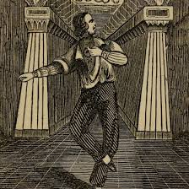[41]

**James O’Connell: The Tattooed Man**

In 1837, James O’Connell took the stage for the first time, performing in a drama at the Franklin Theater based on his experiences in captivity among the people of Pohnpei.[42] O’Connell was an Irish sailor who arrived in Micronesia in the early 1820s, who then lived among the indigenous population for over eleven years.[43] During his time in Pohnpei, O’Connell was tattooed, and he eventually made his way off the island and came to New York. These are the only absolute facts that we can trust regarding O’Connell’s adventure story, as the only documentation of his experiences, entitled *A Residence of Eleven Years in New Holland and the Caroline Islands,* published in 1836, were written by O’Connell himself. However, O’Connell’s performance, his book, and the way his show was advertised over the course of his career provide insight into how his tattooed body was used to create a narrative about life among ‘uncivilized savages.’

First, O’Connell’s narrative offers insight regarding how the ex-sailor characterized his time in Pohnpei for a literary audience. According to O’Connell’s *Residence*, he and his crew were on their way to Japan, by way of the South Pacific, when they were shipwrecked on the island of Pohnpei in the year 1826.[44] Upon landing in Pohnpei, O’Connell and his surviving shipmates were taken captive. According to O’Connell, his shipmates had “feared the Indians were cannibals,” (they weren’t) but O’Connell himself had enough experience with cultures in the surrounding islands that he could tell that “they intended us no harm.”[45] Two things are striking about O’Connell’s language in this early interaction with the Pohnpeians; one, O’Connell calls them “Indians,” and, two, he insinuates that they were “cannibals.” The fact that O’Connell used the vernacular typically associated with Native Americans is quite telling as the performer was obviously associating the Pohnpeians with America’s indigenous populations. In calling the Pohnpeians Indian, O’Connell implicitly suggested a commonality between the foreign island culture of Pohnpei and Native Americans who held a special place in the Euro-American imagination as an enemy.

Further, O’Connell suggests that the Pohnpeians were cannibals, despite the fact that he knew at the time of writing his narrative that they were not. The act of cannibalism is arguably the most taboo act one can commit in Euro-American culture, so the writer’s implication of cannibalism was likely meant to shock his audience. Within a multitude of travel literature, cannibalism is often attributed to foreign cultures who were considered uncivilized.[46] Though cannibalism was practiced by certain cultures around the world at one time or another, the suggestion that a non-Western people practiced cannibalism was often a tool to remark upon the ‘uncivilized’ nature of a foreign culture. O’Connell’s use of these terms within his description of his first meeting with the Pohnpeians directly suggests that the writer wanted to establish a clear and inherent difference between himself, his audience, and the people of Pohnpei

O’Connell goes on to explain that because he knew the Pohnpeians meant him no harm, he “was brave and chose to meet the natives while dancing an Irish Jig for their entertainment.”[47] According to the story, this delighted the natives so much that they brought O’Connell and his shipmate George Keenan with them to their village, and then proceeded to tattoo the men as a ceremony of assimilation.[48] Although O’Connell suggests that his tattooing was against his will, he states that he accepted his fate “like a martyr.”[49] On the other hand, his shipmate Keenan “swore and raved,” when receiving his tattoo, which caused the Native women to mimic and mock him later.[50] Though the sailors found the tattooing to be unpleasant, O’Connell states that his captors “continued to treat us with great hospitality and kindness.”[51] O’Connell claimed that his tattooing was a sort of marriage ceremony, and, due to his exceptional courage and bravery during the tattooing, the island chief’s daughter chose him for marriage. As for his shipmate, Kennan was wedded to a wife of “no rank” because of his “unwillingness to submit to the tattooing.”[52] O’Connell’s narrative goes on to describe his life among the Pohnpeians, including local customs, war tactics, his marriage, and the birth of his children. According to O’Connell, the two sailors were saved after noticing, and subsequently boarding, an American vessel called the *Spy of Salem*, never to return to the island.[53]

O’Connell’s *Residence* details his time among the Pohnpeian people, but aspects of his story clearly suggest that the sailor was worried, if not obsessed, with projecting a sense of masculinity upon his reader. For example, he was brave when the sailors first met the Pohnpeians by dancing instead of cowering, he bore his tattoos without crying out, he was married to an island princess, he claimed that his son could one day become chief of the island, and he claimed to have fought alongside the Pohnpeians against invading peoples. Overall, O’Connell painted himself as the strongest, smartest, most capable person on the island. This aspect of O’Connell’s narrative screams of hyperbolic storytelling, but is enlightening regarding how he wanted to project himself to his audience.

Though some of O’Connell’s narrative painted the Pohnpeians as one-dimensional, uncivilized savages, *Residence* also provides the reader with some nuanced representation of the native population. For example, O’Connell calls his father-in-law a “practical joker,” he tells stories of his marital joys and troubles, he talks about his children’s behavior, he discusses his relationships with other members of the group; basically, part of O’Connell’s recollection of his time in the Pacific Islands effectively humanized the people that took care of him and George Keenan.[54] In fact, O’Connell never refers to himself as a captive, rather, he paints himself as an outsider who was fully accepted by, and assimilated into, Pohnpeian culture. The sailor’s only direct reference to a captive status is in one statement where he calls the Pohnpeian Chief “my new friend-or master, or owner – I do not know how exactly he considered himself.”[55] This statement infers some complexity regarding the relationship between the shipwrecked sailor and the Island Chief, for O’Connell sees him as a friend but also acknowledges his status as a subject of the Chief. O’Connell further complicates his relationship with the Pohnpeians as he states, “after George and I had become habituated to their customs, and learned to appreciate their character, we resigned ourselves to circumstances, and were content in the absence of almost all hope of escape, to be happy.”[56] He goes on to claim, “Some people claiming to be civilized might take a lesson from the humanity of these people to shipwrecked mariners.”[57] Most of O’Connell’s work clearly paints the sailor as a masculine survivor of captivity among a ‘primitive’ culture, however, his humanizing language in some places complicates his narrative and presents more complex discussions of a foreign culture.

To be clear, O’Connell’s narrative is also deeply problematic regarding how the sailor discussed the native population. O’Connell consistently refers to the native population as savages, but it would be anachronistic to see that as blatant racism: that is simply how European peoples talked about indigenous populations at the time. However, early in the book O’Connell goes on an overtly racist diatribe about the people of New Holland. For example, when discussing the natives of New Holland, who lived in close proximity to Pohnpei, O’Connell states, “The connecting link between apes and men…and, particularly when old, resemble the monkey more than any other human beings do.”[58] Within a few pages of his narrative, O’Connell claims that in New Holland, marriage is established by forceful rape, that the people are drunk, lazy devil worshiping, promiscuous, child murdering, filthy, cannibals.[59] On civilization, the sailor claims, “Never in my life before had I seen such a complete degradation from civilization to the lowest scale of human existence…the probability is, however, that the civilization of the natives of New Holland will…be synonymous with their extinction.”[60] Though this language is likely shocking to a reader in the twenty-first century, it would be fair to assume that the O’Connell was establishing an essential difference between ‘bad’ natives and the native people that he lived among in Pohnpei. He does use some similar descriptions of the Pohnpeians, but he is never so overtly negative about their character. In the early nineteenth century, the idea of ‘going native’ or accepting the indigenous culture, was severely looked down upon by Western peoples. By creating the fantasy of the drunk, filthy, cannibals of New Holland, O’Connell then moves on to tell about his time in Pohnpei with the more civilized, but not white-man civilized, natives.[61] This effectively allowed O’Connell to keep his whiteness, to forgo charges that he ‘went native,’ and move on to telling an adventure story of life among indigenous peoples without drawing the ire of his ‘civilized’ reader.

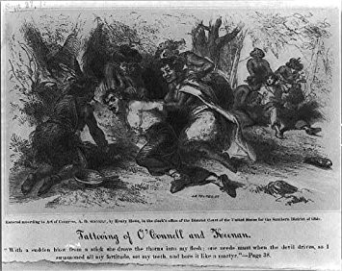[62]

Where *Residence* represents the Pohnpeian people with at least some complexity, O’Connell’s stage performances diminished their culture to simple caricatures. An advertisement for O’Connell’s show in 1837 includes a woodblock print of the performer being held down and tattooed by two native women and large lettering that promised the audience that his show would include a shipwreck and performance of an “Irish Jig.”[63] O’Connell’s show was not only an entertaining adventure story but also a show that allowed his white audience to gaze upon a man who had been marked by a foreign culture. Historian Albert Parry states that the audience “gazing at the tattooed man in the sideshow, relives his own past of untold centuries back. Moreover, he can now imitate the freak…and thus blissfully revert to his own distant, primitive type.”[64] Standing on stage and showing off his tattoos, O’Connell gained authority as a living example of ‘primitive’ culture who was then able to tell of his experience to his audience with a sense of authority. In doing so, the Tattooed Man became the first American theatrical performance to discuss the ‘uncivilized’ nature of foreign people in the Pacific Islands.

In 1976, Micronesian anthropologist Saul Riesenberg published a detailed exposition on the accuracy of O’Connell’s narrative, ultimately coming to the conclusion that he was a pathological liar, and most likely an ex-convict. However, more recent scholars, Juniper Ellis and Lars Krutak, Annie Werner, all come to the conclusion that while O’Connell’s personal adventures were likely exaggerated, his depiction of Pohnpeian customs is basically accurate.[65] Thus, O’Connell’s written work and the early years of his performances offer insight into the showman’s seminal representations of Pohnpeian people and customs. Though O’Connell likely exaggerated his own experiences, he was delivering relatively accurate information about Pohnpeian culture to his audience.

James O’Connell, “The Tattooed Man,” was performed as a stand-alone theatrical performance in 1837, but by 1840 his spectacle had been turned into a sideshow for other, larger productions.[66] In August of 1840, The *New York Herald* published an advertisement for the Chatham Theater’s production of the play *The Muleteer of Palermo* which included an advertisement for O’Connell’s sideshow. The ad states, “O’Connell, the tattooed man, will appear in one of his peculiar parts.”[67] Notably, there is no description of his show, simply a statement that he is tattooed and will appear. As a sideshow, one could assume that he simply danced a jig, showed off his tattoos, and told a short story of captivity among foreign peoples.

In 1841, O’Connell was performing at a failing museum called the Scudder’s American Museum on the corner of Broadway and Ann Street in New York City. That year, P.T. Barnum bought the museum and immediately got to work trying to make the museum profitable. Barnum has been credited with bringing acts like the ‘freakshow’ into the mainstream of American popular entertainment because of his unique penchant for advertisement. An example of his advertising style can be found in his promotion of James O’Connell’s show in November of 1842, which states, “Mr. O’Connell, The Tattooed Man, will appear in his celebrated dances, and give a historical account of his sufferings for eleven years, while a prisoner in the hands of barbarous savages.”[68] Unlike the earlier advertisement, this statement highlights O’Connell’s captivity, and dramatizes his time among the “barbarous savages.”[69] An ad for O’Connell’s show at the Amphitheater in New York less than a week later mimics Barnum’s dramatization as it states, “O’Connell…is to appear and exhibit the extraordinary dance that once saved his life while in captivity amongst the savages.”[70] This new marketing strategy emphatically highlighted the literary tropes of adventure stories by painting O’Connell as a masculine survivor of ‘savage’ captivity.[71] It also emphasizes an educational aspect of the show as O’Connell was going to give a “historical account,” thereby insinuating that his show was going to include informative information about the foreign cultures he lived among.

The fact that the advertisements for O’Connell’s shows, and presumably O’Connell’s performances, emphasized captivity, danger, and barbarism when the showman’s written work did not, suggests that his story was exaggerated to be more entertaining for a live audience. In a sense, his story was taken from him and retooled by show managers to appeal to a wider audience. It is also telling that the changes in his story were directly related to the barbarism and captivity aspects of his story, rather than the more nuanced discussions of culture that are present throughout *Residence*.

The escalation of xenophobic rhetoric in O’Connell’s show is further exemplified by an advertisement for his performance in Louisiana in September of 1852. O’Connell had traveled to New Orleans as a part of the Star Spangled Circus, and upon their arrival, a local newspaper wrote an article depicting O’Connell’s captivity story. The article states: “He found the Island inhabited by a set of heathen Indians, and ‘salvage [*sic*] men,’ unacquainted with the common decencies and amenities of civilized life, and as apt to gobble him up without basting or roasting, as they would a lizard or snail.”[72] The article goes on to suggest that to escape being eaten by the “cannibal islanders,” O’Connell “devised a plan to cheat the barbarians.”[73] After seeing the “inhuman antics of the savages waiting to receive him,” O’Connell decided to dance a jig to save his own life.[74] According to this article, the natives loved the dance so much that they accepted the shipwrecked O’Connell, but “His companions, as a matter of course, were eaten.”[75] According to this version, O’Connell was subsequently married to “the King’s favorite daughter,” but not before they “made O’Connell ‘one of em’ by ‘tattooing’ him after the style of the ‘salvages’ [*sic*]… [which] made the sailor look “very much like the zebra.” O’Connell escaped after living with “these ‘people’” for so long that their lifestyle became unbearable, and visions of his “quiet cottage beyond the billowy deep” became so strong that he chose to leave the island. Apparently, O’Connell escaped after he found a “white settlement” on the island and returned to America to perform in the circus.

This incredibly xenophobic, overly-dramatized version of O’Connell’s story perfectly exemplifies how his narrative was appropriated and subsequently used as evidence of the uncivilized and barbaric practices of foreign island cultures. When O’Connell first came to the New York stage in the late 1830s, he was a tattooed white man who was going to dance and tell of his adventures on the South Seas. By the 1850s, his show had become a full-on spectacle, complete with a white protagonist who survived captivity by outsmarting the “savage cannibals,” but not before sexually dominating the “King’s favorite daughter.” Further, the author’s suggestion that the “heathen Indians” were “unacquainted…with civilized life” establishes that the author was remarking upon the lack of civilization of the Pohnpeians, while also establishing O’Connell as a masculine protagonist. Clearly, by the early-1850s, O’Connell’s show had gone from showing his tattoos off and telling of the manners and customs of foreign people, to outright xenophobic explorations of the white man’s interaction with so-called uncivilized peoples. As such, the sailor’s real-life adventures, although likely hyperbolic, had taken a back seat to a message of white superiority over uncivilized, heathen cannibals.

James O’Connell died in 1854 while he was traveling the country with Dan Rice’s circus. Prior to that, O’Connell enjoyed an eighteen-year career and performed for millions. Though the showman had a penchant for exaggeration, his performance offers insight to a different path performers could have taken within popular entertainment. When O’Connell arrived, he wrote a book about his travels, he performed reenactments of his time in Pohnpei, and he taught his white audience various aspects of a foreign culture. By the time he died, his performance was one that played on American’s imagination of the exotic, uncivilized cultures of the outside world. The subjects of O’Connell’s adventure story no longer presented any nuance; they were simply uncivilized cannibals. As such, O’Connell’s career serves as a microcosm of human exhibition in the nineteenth century, for by the late nineteenth-century American entertainment culture became inundated with using non-white bodies as caricatures of foreignness that suggested a superiority of Western culture. These shows would go on to become a major part of the American entertainment industry for generations.

**P.T. Barnum and America’s Obsession with ‘The Other’**

Phineas Taylor Barnum is widely considered to be the most influential entertainer of the nineteenth century. His museum and traveling circuses were attended by tens of millions of Americans, and his business practices paved the way for the development of America’s commercialized entertainment culture.[76] Barnum’s exploits, his life, and his effect on the society around him have been well covered by myriad historians and biographers, but his importance to this work lies in his role as one of the most prolific exhibitors of the human body in the history of popular entertainment. Barnum took small sideshow acts like giants, Siamese twins, dwarfs, people with missing limbs, and many other so-called ‘freaks’ and he turned them into major attractions for a working-class audience. He did so through clever advertising and showmanship by concocting elaborate backstories that made his acts more interesting and fantastic. Essentially, Barnum pulled the freak show out of small inns and taverns and brought it into the mainstream. What is often left out of Barnum’s history is how his human exhibitions intersect with the dissemination of xenophobic ideas about foreign cultures that laid the foundation for American imperialism overseas. Throughout the following section, my work will trace how Barnum’s entertainments helped propagate ideas of foreign island cultures as uncivilized savages who were in need of Western civilization.

In December 1841, Barnum entered the entertainment business in New York City after he bought the failing Scudders Museum and renamed it the American Museum.[77] For a few years previously, Barnum had managed some sideshow performers, but it was the American Museum that would make Barnum a major name in the entertainment business. Barnum came to New York “on the eve of what can only be termed an amusement explosion,” claims Harris.[78] Museums had long been a part of major cities like Philadelphia and New York City, but their purposes were typically for the enlightened refinement of their audience. When theaters began to pop up all around the New York City, they created more competition for the public’s attention, causing museums to have a harder time maintaining a profitable business.[79] In this context, Barnum saw opportunity. After purchasing Shudders, Barnum quickly moved to fill his museum with as many ‘curiosities’ as he possibly could. The *American Museum*, thus, became a stationary location where white audiences could go see the lowbrow ‘freakshow’ that was disappearing from more high-class institutions.

Part of Barnum’s genius lies in his understanding of the growing conservative, Christian middle class who considered the theater to be a space of immorality and vice. Barnum saw an opportunity to appeal to this specific segment of society who wanted to be entertained by public performance, but did not want to attend the ‘immoral’ low-class theater, or the highfalutin upper-class theater or museum. Thus, he sought out to create a business that was moral and family friendly, but also amusing. According to Neil Harris, Barnum’s *American Museum* was a place where the showman could “mount dramatic entertainments or present variety acts under the guise of education and public enlightenment.”[80] For Harris, Barnum exploited the educational aspect of the museum by presenting his audience with legitimate educational content, but then exploited that authority by including shows that were presented as educational but were, in fact, complete fabrications. Further, Harris argues that the audience was not completely ignorant to the fact that there was a certain level of trickery included in some of Barnum’s shows. Harris calls this phenomenon the “operational aesthetic,” which supposes that Barnum’s audience exhibited a sense of playfulness with the truth and reality of the showman’s ‘curiosities.’[81]

Barnum learned early in his career that his American audience was susceptible to humbug, and that the ambiguity of truth could be profitable. Barnum’s first exploit into the popular entertainment industry was in 1835 when he put on a show at Niblo’s Garden featuring an eighty-year old slave by the name of Joice Heth. Barnum claimed that Heth was the 161-year-old former “mammy” of George Washington.[82] Audiences were encouraged to ask her questions about her life, and she would give details that supported the farce. Barnum travelled around New England with Heth for seven months, until her death in 1836.[83] According to a newspaper article in the *New York Herald*, upon her death, Barnum had Heth’s autopsy performed in front of paying customers to prove that she was, in fact, over one hundred and sixty years old.[84] When the coroner proclaimed that Heth was approximately eighty years old, Barnum simply claimed that the body was an imposter and the real Heth was in Connecticut.[85] Barnum profited around $10,000 for the autopsy.[86] This early endeavor in the entertainment business showed the young Barnum that “the public would be more excited by controversy than conclusiveness…The only requirement was to keep the issue alive and in print,” state Harris.[87] It was also Barnum’s first human exhibition; an act that would later come to define his career.

After purchasing the *American Museum*, Barnum inherited some of the previous museum’s sideshow acts, including James O’Connell, “The Tattooed Man,” and his story of captivity among the Pohnpeians.[88] Working for Scudders, O’Connell had been a simple freakshow among the many other ‘oddities.’ However, once Barnum took over the museum he began running ads for the museum featuring, in large bold print, “MR. O’CONNELL THE TATTOOED MAN,” who was going to “give an historical account of his sufferings for eleven years while a prisoner in the hands of barbarous savages.”[89] Whereas O’Connell had been just another sideshow, Barnum made him one of the main attractions of his museum and drew crowds in with his incredible story of captivity among the ‘savages.’ When O’Connell took the stage, he performed an Irish jig, showed off his tattoos, and told the audience of his time in Pohnpei, therein becoming the first exhibition in America that was intended to represent and discuss the customs and civilization of a foreign island culture.[90] Soon after Barnum employed James O’Connell, the showman sought out foreign peoples to put on display at his museum. In the process, Barnum began to exploit American fantasies about the outside world.

Though Barnum employed a variety of foreign peoples as sideshow entertainers, in the early years of the American museum the showman had a clear interest in exhibiting cannibals. Cannibalism was a particularly hot topic in America in 1838 after the United States “sponsored an expedition to Fiji, to survey the islands and investigate a massacre of the crew of an American vessel.”[91] According to Robert Bogdan, this expedition caught the interest of the American public, and after the crew reported back that they had seen the ceremonious consumption of a human eye, the public became convinced that “human flesh was a mainstay of the Islander’s diet.”[92] Further, the expedition, led by Charles Wilkes, concluded that an American ship had been shipwrecked and their crew eaten by Fijian natives.[93] This act was, and still is, particularly taboo in Western culture, and, for Westerners, claims of cannibalism served to demarcate the South Pacific Islanders and explicitly ‘uncivilized.’ Indeed, claims of cannibalism can be found in numerous travel journals of Western explorers throughout the eighteenth century, including one of the most famous travel journals: Captain James Cook’s, *A Journal of a voyage round the world in HMS Endeavour 1768-1771*.[94] Although some cultures did engage in the act of cannibalism, the fact that the accusation came up so frequently suggests that Western explorers often exaggerated a foreign culture’s primitiveness by simply claiming that they were cannibals. Likely in the same vein, according to Bogdan, “With his keen business acumen, Barnum sensed the appeal cannibals might have” for his paying audience.[95]

After O’Connell’s successful exhibition, Barnum attempted to exhibit an alleged Fijian cannibal named Vendovi, but was ultimately unsuccessful after the man died of tuberculosis upon arrival in New York.[96] However, in 1845, Barnum acquired another supposed cannibal who he exhibited as the “New Zealand Canibal [sic] chief” alongside a “Bedouin tribe.”[97] Barnum also exhibited “Two cannibals of the island in the South Pacific’ in the mid-1840s.[98] Though Barnum did exhibit people from other areas of the world, it is clear that he intended Pacific Islanders to serve as a specific type of character in his exhibitions; the primitive cannibal. Following the successful exhibition of supposed cannibals, Barnum began to show a “growing interest in racial displays,” claims cultural historian Bluford Adams.[99] This interest would come to define his particular brand of entertainment over the course of his career.

Although it was not likely the showman’s intent, Barnum’s exploitation of the foreign ‘Other’ as a ‘freak’ helped to create a framework for xenophobic ideas about foreign island cultures. Barnum was an entertainer who was merely trying to fulfill his audiences’ interests. However, in promoting shows that represented island peoples as uncivilized, man-eating, barbarians, he was teaching his audience how to think about the people in island nations. Essentially, Barnum used his racial displays to establish a quantifiable difference between his uncivilized exhibitions and his civilized white audience, a juxtaposition served to dehumanize foreign peoples in a spectacle for mass consumption.

**Civilization and Manifest Destiny**

Whether it was his intention or not, Barnum’s exhibition of “uncivilized” cultures in the mid-nineteenth century was consistent with the Euro-American concept of manifest destiny. By 1845, the idea that Anglo-Saxon Americans were destined by God to bring American ‘civilization’ to ‘savage’ cultures began to proliferate in American media sources. This idea is best exemplified by the phrase “Manifest Destiny,” coined by John O’Sullivan in 1845. In an article entitled “Annexation,” published in *The United States Magazine and Democratic Review*, O’Sullivan expounded his theory for the future of America that included the consolidation of ‘American’ lands from the Atlantic to the Pacific.[100]

The key concept of Manifest Destiny was the idea that the ‘civilized’ Euro-Americans were ordained by God to ‘civilize’ the rest of the country by force. White Americans, “armed with the plough and the rifle” would spread across the land, “marking its trail with schools and colleges, courts and representative halls, mills and meeting-houses.”[101] O’Sullivan’s concept of ‘Manifest Destiny’ was originally meant to relate to the seizure and ‘civilization’ of Native American peoples, however, the idea of ‘civilizing’ non-white cultures was quickly employed by the press to argue for American expansion into foreign lands that laid outside of the North American continent. Manifest Destiny was predicated on the idea that it was America’s job to civilize underdeveloped land, so it only makes sense that the press soon began to look at other so-called uncivilized lands and people that needed to be brought into civilization. For example, in a *New York Daily Times* articlefrom 1852, entitled “The Science of Manifest Destiny,” the author suggests that America needed to expand into Cuba and Hawaii in order to spread American Republicanism.[102] The article expresses a clear, and explicit claim that white-Western men were superior to everyone else as the author states, “Everywhere beyond our own borders, on this Western hemisphere, do we see the need of the steady, ballasting traits of Anglo-Saxonism.” [103] The author then states, “It will never do to argue the practicability of our system beyond the confines of the race until the experiment is abundantly tried,” which suggests that the author believes that white, Westerners needed to test whether or not it was practical to attempt instilling Western style governments in non-white nations.[104] Another article, published in the *New York Daily Times*, also exploits the idea of Manifest Destiny to argue for American imperialism as the author states, “Manifest destiny and the horizon move together. The national progress is best described as expansion.”[105] The author goes on to argue for the annexation of Hawaii and other South Pacific islands, suggesting that Americans would not meet much resistance because Christian missionaries had made the Island peoples a “conquered culture.”[106] Basically, the authors here were suggesting that white Americans should see all ‘uncivilized’ lands through the lens of Manifest Destiny and begin conquest of any foreign lands that did not exhibit the traits of Western culture.

The importance of manifest destiny to my analysis lies directly in the concept’s main tenet: that it was the white man’s job to civilize the supposedly uncivilized. According to Amy Greenberg, the idea of manifest destiny was directly tied to contemporary American’s sense of manhood and, in turn, their thirst for domination over other cultures. Greenberg argues that the concept of manifest destiny was used as an excuse for a variety of America’s conflicts throughout the nineteenth century, such as the constant conquest of Native American lands, and the Mexican American War, however, she neglects to assess the connection between the foundational ideas of manifest destiny and the representation of foreign peoples urban popular entertainment. At the heart of both manifest destiny and P.T. Barnum’s human exhibitions is the concept that the ‘other’ is uncivilized, thus, both manifest destiny and Barnum’s exhibitions were simply symptoms of a larger discourse regarding the idea of civilization and how that plays into the relationship between cultures.

In the early years of his career, P.T. Barnum was continuously putting people from the South Pacific on stage as living examples of uncivilized cultures. His shows specifically emphasized characteristics, such as cannibalism or tattooing, that projected an implicit message that the performers on stage, and the cultures they come from, were uncivilized. In a society that was growing more and more confident that it was their duty to dominate the uncivilized people of the world, Barnum’s public exhibitions played upon his audience’s sensibilities and turned cultural domination into an extravagant spectacle. For the rest of his career, Barnum’s entertainments offered a wide variety of content, but the concept of a civilized white, Anglo-Saxon culture against the barbarism of non-white Others was never far from the main stage.

**Barnum Takes His Show on the Road**

Throughout the 1850s and early-1860s, Barnum continued to exhibit all things exotic in his American Museum. However, on July 13, 1865, P.T. Barnum’s museum burned to the ground after more than two decades of success in the New York entertainment business. According to the *New York Times*, approximately one hundred people were injured, and the fire caused around one million dollars in damage.[107] Luckily, the fire happened outside of business hours, so there were no deaths, but the American Museum was completely destroyed leaving Barnum with nothing to salvage from his eccentric collection of ‘curiosities.’ Barnum quickly invested in procuring a new collection of exotic curiosities, and opened the New American Museum in November of 1865. However, three years later, that museum also burned down.[108]

Following the destruction of the New American Museum, Barnum spent a few years trying to get into politics, and was elected mayor of Bridgeport, Connecticut, but he eventually decided to return to the public entertainment business and dedicate his time to the circus industry. Barnum, along with his business partner C. W. Coup, set out to create one of the most extravagant traveling circuses in the country, entitled the *Greatest Show on Earth*. The circus was a massive endeavor that included many of the attractions that had made his museum so popular: namely, a hippodrome (theater), a menagerie (collection of animals), and a museum of ‘curiosities’. According to Harris, Barnum and Coup revolutionized the way circuses travelled from city to city, likening the traveling circus to military mobilization.[109] Unlike the American Museum, which was a stationary building in New York City, Barnum’s circus brought his racial displays into small towns across the country. Americans no longer needed to visit a large city to enjoy the exploitation of the outside world, the world came to them.

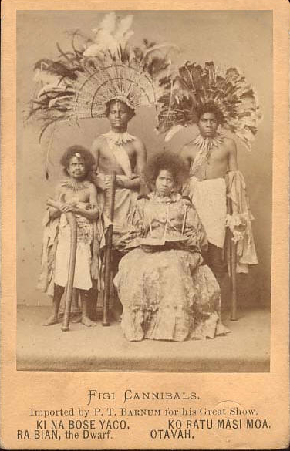[110]

Much like the American Museum, the exotic and foreign continued to be a major facet of Barnum’s circus. In 1872, at the beginning of his career in the circus business, Barnum once again sought to exploit his audiences’ fear of cannibalism. According to an advertisement for an exhibit titled “The Fiji Cannibals,” Barnum had brought four cannibals to the United States to exhibit in his traveling circus. The backstory for the four “Fijians” was that there had been a rebellion in Fiji, in which two Christian missionaries were taken to be eaten by their captors. However, the Fijian king had converted to Christianity, so he sent out warriors to rescue the missionaries. Barnum claimed that the four Fijian circus performers were war prisoners from that rebellion. According to Barnum’s sixteen-page advertisement for the Fiji Cannibals, the captives were originally destined “to have their tongues cut out, their brains eaten and their skulls converted into drinking cups, while the bones of their bodies were to be made into ornaments to be worn by the vanquishers.”[111] However, the missionaries supposedly saved the four by suggesting that they be sent to the United States to be introduced to the “modes and customs of civilization.” After their arrival in America, Barnum had the famous Mathew Brady take photographs of the “cannibals” and produced cabinet cards (mounted photographs) as advertisements for their exhibition in upcoming shows. Unfortunately, one of the Fijians died right before they were to be exhibited, and Barnum used his death to promote the exhibition further, suggesting that he had gotten sick and the others ate him. Though all of this might have been entertaining, none of it was true. The “Fiji Princess” was actually from Virginia, and the men, though born in Fiji, had been raised in California by missionaries. None of the four were cannibals.[112] In true Barnum fashion, the “Fiji Cannibals” served as an entertaining exploitation of white-American’s fears of the outside world. They were not cannibals, but their dark skin alone made them believable as uncivilized cannibals to a white audience.

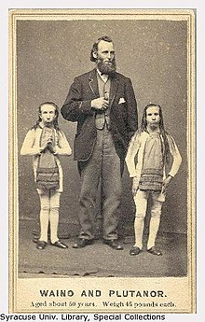[113]

Following the exhibition of the “Fiji Cannibals,” in 1882, Barnum procured “The Wild Men of Boreno” for his traveling circus. “The Wild Men of Boreno” were a relatively popular traveling freakshow in the United States during the 1860s and early-1870s, however, they became widely known after they ended up working for P.T. Barnum. The show included two dwarfs with severe mental disabilities, called Waino and Plutano, who went on stage, often in chains, and thrashed around and acted like animals.[114] Further, the two would often perform while, “talking strange gibberish and scurrying about the platform snapping and snarling,” states Bogdan.[115] Along with their theatrical performance, a pamphlet was distributed, entitled “ What We Know About Waino and Plutano, The Wild Men of Borneo,” which told an exaggerated story of how the two men were captured.[116] According to Bogdan, the pamphlet also included a description of Borneo that accurately described the country’s flora and fauna, but “outlandishly embellished tales of the indigenous people.”[117] The pamphlet claimed that the island was inhabited by such an isolated race of people that they were basically half animal, half man, and wholly lost to civilization.[118] The two men, born Hiram and Barney Davis, were actually born in the United States, and grew up on a farm in Ohio before their mother sold them to a showman named Layman Warner to be exhibited in traveling freakshows.

Like the ‘cannibals,’ the ‘wild men’ were put on stage as representatives of some far-away island culture. Both shows presented audiences with dangerous, uncivilized, and in the case of the ‘wild men,’ sub-human performers who implicitly played upon the audiences’ assumptions about native peoples in foreign lands. However, the ‘cannibals’ were not cannibals, any more than the ‘wild men’ were wild. These were spectacles, curated by showmen, performed by performers, to entertain a white-audience that was accustomed to believing that people from the outside world were uncivilized sub-humans. By using these shows to spread inaccurate and derogatory ideas about foreign peoples, showmen like Barnum were normalizing the dehumanization of actual, real-life island peoples.

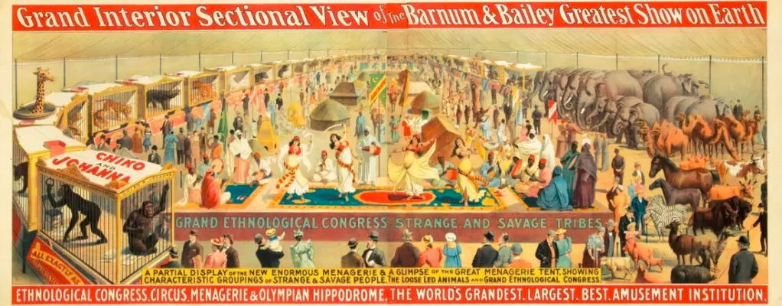

Throughout most of his career, Barnum’s racial displays were produced in the traditional style of the freakshow. He put people on stage from Fiji and New Zealand, but sold tickets to their exhibition because they were ‘cannibals.’ From Africa, he put on a show exhibiting an unevolved human.[119] From South America, mentally handicapped people who were supposedly Aztecs.[120] From Borneo, supposedly sub-human. In essence, Barnum’s shows created a strong link between the grotesque and the foreign. However, in 1883, Barnum created a show that removed most of the traditional freakshow characteristics and displayed foreign peoples simply because they were foreign and ‘uncivilized.’ The performance was called the “Ethnological Congress” and it included “representatives of noble and peculiar tribes…types which otherwise” the viewer “would never see, as they can only be sought in their native countries.”[121] The Ethnological Congress, was basically a parade with hundreds of people from around the world dressed up in exotic clothing that was meant to be representative of the traditional, non-Western garb of their respective countries. Barnum states that he wanted to form “a collection, in pairs or otherwise, of all the uncivilized races in existence.” [122] Unlike the former freakshow, this performance exploited the Western gaze and provided Barnum’s white audience to look upon the ‘Other’ from the comfort of their own American city. In creating this racialized spectacle, Barnum was in control of how these people looked on stage, how they were dressed, and how they were presented to the audience thereby placing the agency of representation in the hands of a white, Western businessman that was attempting to exploit Otherness for profit. Within this show, Barnum was responsible for creating the fantasy of what the outside world looked like, and he used his “collection” to create identifiable caricatures of the many cultures he aimed to represent.

Along with the collection of human representatives of race, Barnum was also seeking more traditional non-white entertainers that could perform in his show as sideshow entertainers and freakshows. Barnum states, “My aim is to exhibit to the American public not only human beings from different races, but also, when practicable, those who express extraordinary peculiarities, such as giants, dwarfs, singular disfigurements of the person, dexterity in the use of weapons, dancing, singing, juggling, unusual feats of strength or agility. &c.”[123] By mixing the freakshow acts with his racial displays, Barnum curated an orientalist fantasy of the Other that played upon his audience’s sense of racial and cultural superiority over the ‘uncivilized’ peoples of the world.

Barnum’s “Ethnological Congress,” though implicitly racist, must be understood as a product of contemporary pseudoscientific thinking. According to Adams, in the late-nineteenth century, academics in the new field of Ethnology were searching for proof that Anglo-Saxon peoples had literally evolved from darker skinned races that still inhabited Africa and Asia.[124] They had tried measuring facial features, brain, hair, intelligence and other factors to try and prove their theories but none of those studies found any conclusive evidence of white superiority.[125] Ethnology was basically a racist ‘science’ that grew out of Charles Darwin’s theory of evolution. Darwin’s *On the Origins* of Species, published in 1859, argued that all species shared common ancestors, and the differences among species were the result of millions of years of species adapting to their environments. Though Darwin did not apply his theory to human beings, Ethnologists attempted to apply the theory of evolution to humans under the assumption that different races of man represented different stages of the evolutionary process. Unsurprisingly, Ethnologists found no conclusive evidence to support the idea that some races of man were less evolved, however, Adams states, “where ethnology failed, the Ethnological Congress succeeded…the bodily Otherness of the Congress’s freaks was beyond dispute.”[126] Adams’ statement here is tongue-in-cheek, as the historian’s point is that Barnum succeeded where ethnological “scientists” had failed. Barnum’s audience only needed to look upon the ‘uncivilized’ specimens and be reassured of their racial superiority.

Barnum’s racial displays employed the contemporary field of Ethnology, but it is likely that the showman did not agree with its main premise: that some races were sub-human. In his autobiography, *Struggles and Triumphs*, Barnum clearly argues against the idea that non-white races were scientifically inferior to Anglo-Saxons. Barnum states, “You may take a dozen specimens of both sexes from the lowest type of man found in Africa; their race has been buried for ages in ignorance and barbarism, and you can scarcely perceive that they have any more of manhood or womanhood than so many orang-outangs or gorillas. You look at their low foreheads, their thick skulls and lips, their woolly heads, their flat noses, their dull, lazy eyes, and you may be tempted to adopt the language of this minority committee [of ethnologists] and exclaim: Surely these people have ‘no inventive faculties, no genius for the arts, or for any of those occupations requiring intellect and wisdom.’ But bring them out into the light of civilization…and the human soul will begin to develop itself.”[127] Despite the fact that Barnum may have disagreed with ethnologists regarding the scientific basis of their racial assumptions, it is also clear that he believed that bringing Western civilization to foreign peoples was the only way for them to become civilized. Thus, the Ethnological Congress was created by a man who did not necessarily believe that foreign people were scientifically inferior, but did believe that they were culturally inferior because of their lack of influence from Western civilization. By creating a spectacle out of race in his Ethnological Congress, Barnum was attempting to exemplify the many ways foreign people differed from his white audience in an attempt to suggest that, though they are uncivilized and savage now, they could become civilized if given the chance. This, mixed with the contemporary concept of manifest destiny, made Barnum’s Ethnological Congress a spectacle of Western imperialism. For, according to the main tenet of manifest destiny, if the subjects on stage were uncivilized, then it was only a matter of time before Western powers brought civilization to their shores through conquest.

**The World’s Columbian Exhibition**

P.T. Barnum died in 1891, but that did not stop the showman’s influence on American popular culture. In 1893, the World’s Columbian Exhibition was held in Chicago, and, according to Bluford Adams, “P.T. Barnum was very much a presence.”[128] With the circus, Barnum traveled the country, exhibiting his Ethnological Congress in a space that was understood to be entertaining and extravagant. However, when the Columbian World’s Exposition appropriated Barnum’s main attraction and included its own ethnological exhibits, Barnum’s imperialist spectacle officially infiltrated a respectable, authoritative space for learning. Even in the Exposition, the ethnological shows were still fantasy, but the World’s Columbian Exhibition did not operate under the same “operational aesthetic” that characterized Barnum’s entertainments. With a Barnum museum or circus, the crowd was aware that there was some level of trickery or spectacle, which was an accepted feature of the entertainment. However, employing Barnumesque racial displays in a respectable World Exhibition took the practice out of the context of the spectacle and placed it in an educational context. Essentially, the World’s Columbian Exhibition made Barnum’s exploitation of ‘uncivilized’ races a part of an authoritative institution that was not widely understood to be creating fantasy. Barnum’s spectacle had become mainstream.

World’s Expositions have an extensive history in Western culture, dating back to 1851 with the first World’s Exposition in London, England. World’s Fairs/Exhibitions typically consisted of a large space (much larger than a fair ground) filled with buildings that represented the many technological, cultural, and industrial advancements from around the world.[129] Many nations also got their own buildings that symbolized the various aspects of the respective country. For example, at the Columbian World’s Exposition one could visit the Agricultural Building to learn about new agricultural techniques, then stop by the French Building to learn about the country of France, and then visit Machinery Hall to learn about new machine technology. The size, design, and the contents of the buildings were all carefully curated to teach visitors about the topic, or country they were ‘visiting.’ On the surface, these events were a celebration of industrialization, art, technology, culture, and globalization that was taking place around the world. According to World’s Fairs historian Robert Rydell, “These events were triumphs of hegemony as well as symbolic edifices.”[130] Rydell argues that the World’s Fair was a place where the powerful could celebrate their domination of the working classes and weaker nations of the world.[131] Within the architecture of the buildings, the artifacts that were chosen to be displayed, and the arrangement of the buildings in relation to one another existed symbolic messages that celebrated the power that the elite held “because of its position and function in the world of production.”[132] As such, these events were effectively celebrations of Western civilization and, in turn, Western imperialism. Attended by over twenty seven million patrons, Chicago’s World’s Colombian Exposition of 1893 is considered to be one of the “culminating U.S. cultural events of the nineteenth century.” [133]

To find Barnum’s influence on the World’s Colombian Exposition in Chicago, one need look no further than the ethnological villages on the Midway Plaisance. Chicago’s exposition was laid out in two distinct sections; the White City and the Midway Plaisance. The White City was the supposed main space for the event and included structures that represented the various nations of the world, and building that housed lecture halls for learning about various subjects. In essence, the White City was what the exhibition was all about; teaching the audience about advancements in Western society. Conversely, the Midway Plaisance was the commercialized section of the event where one could go ride the Ferris wheel, or look upon the sideshow spectacle of the ethnological villages. Midway attendees could visit a variety of small villages that represented the people and culture from various civilized or barbarous areas of the world: including Ireland, Algeria, Dahomey, Germany, Samoa, Java, and Egypt.[134] Within each of these villages, one could gaze upon people and objects that were ‘representative’ of their country’s culture. For example, one of the most popular villages was the Egyptian village which included snake charmers, camels, and scantily clad women doing exotic dances.

What makes the Midway Plaisance so important is the juxtaposition it created between the ‘civilized’ and ‘barbarous’ nations of the world. According to Bederman this juxtaposition was designed to guide visitors to a full appreciation of "the contrast between the civilized White City and the uncivilized native villages.”[135] Unlike the White City with its sprawling attractions and non-linear layout, the Midway was built as on long street where an attendee would walk from civilization into the primitive world. At the beginning of the street, a patron would walk by villages that represented the white countries of Germany and Ireland, then they would proceed past the barbarous but not quite savage Egyptians and Algerians, and finish by walking past the “savage” Samoans, Dahomeyans, and Javans.[136] A writer for the *Chicago Tribune* discussed the Midway Plaisance, claiming that it offered “an opportunity…to the scientific mind to descend the spiral of evolution…tracing humanity in its highest phases down almost to its animalistic origins.”[137]

Adams argues that in the racially charged spectacle of civilization versus savagery, “the fierce Dahomeyans, the sensual Egyptians, and the athletic Moors all had forebearers in his [Barnum’s] shows.”[138] The World’s Columbian Exhibition may have been a celebration of Western advancement and culture, but the commercialized spectacle of civilization that defined the Midway was strikingly similar to the way Barnum had been exhibiting ‘uncivilized,’ foreign peoples for decades previous. This connection was not lost on contemporary Americans as the *New York Times* claimed that the ethnological village at the Midway was the “Greatest Show on Earth;” a direct reference to the late Barnum’s traveling circus.

In the end, P.T. Barnum made a career exploiting his audience’s interest in any and everything ‘exotic.’ Whether it was artifacts, animals, or people, Barnum brought his audience things that they would likely have never seen in their small town, nor in a large American city. However, in doing so, the showman also dehumanized entire populations. To his white audience, the foreign people that Barnum decided to turn into spectacles, became representative of the outside world. As such, his audience was learning how to think about the ‘primitive,’ ‘uncivilized, ‘savages’ that lived far beyond American shores. Every time Barnum put a supposed cannibal on stage, he was simply offering another example of how dangerous and evil the non-white world was. Though it was likely not his intention, this type of dehumanization and spectacle played upon very real feelings among his audience that it was their duty to bring civilization and order to the many uncivilized nations of the world. This makes Barnum’s career relevant not only to the history of popular American culture, but to the history of American imperialism. There were many authors, journalists, politicians, and academics discussing the civilization and savagery among non-white nations during the years of Barnum’s immensely successful career, but with a Barnum circus one could gaze upon the explicit need for civilization for the price of admission.

**The Spanish American War and Images of Imperialism**

During the last years of the nineteenth century, the American government embarked upon a chain of events that led to the conquest of Cuba, Puerto Rico, Guam, the Philippines, and Hawaii. The United States had employed imperialist policies against Native American lands for over two centuries by the turn of the century, but it had never attempted to colonize nations outside of the North American mainland. This changed on April 25,1898, after President William McKinley, with the approval of the U.S. Congress, declared war on Spain allegedly due to the nation’s inhumane reaction to a rebellion in Cuba, one of Spain’s colonies.[139] The war was sold to the American public as a patriotic act to liberate a neighboring country, however, the U.S. government’s real intentions with the ‘liberation’ are made clear by the fact that members of Congress, and American newspapers had been making arguments for expansion into Cuba and the South Pacific Islands for almost half a century before the start of the Spanish American War.[140] The Cuban rebellion against their Spanish colonizers effectively provided the U.S. with the perfect opportunity invade Cuba and realize their true goals of overseas expansion.

Cuba’s rebellion began in 1895, leading to a violent suppression of revolutionary forces by the Spanish military. Between 1896 and 1897 over 400,000 Cuban citizens died as a result of Spanish General Valeriano Weyler’s “Reconcentration Policy,” [141] however, the American public did not show mass support war in Cuba until 1898 after an American ship, the *USS Maine*, sank in the Havana Harbor, killing over two hundred American servicemen.[142] American newspapers quickly blamed Spain for the sinking of the *Maine* and the public subsequently called for war.

The Spanish American War lasted less than four months, ending with a victory for the United States’ military. Both countries then signed the Treaty of Paris on August 13, 1898, in which Spain ceded control of their former colonies Cuba, Puerto Rico, Guam, and the Philippines to the United States of America.[143] American newspapers, who had been heavily involved in garnering public support for the liberation of Cuba, began to question whether or not the United States should colonize their newly acquired territory. The discussion of America’s role with regards to the various island nations sparked a heated debate about the positive and negative aspects of U.S. imperialism within American newspapers and magazines.

According to Bonnie Miller, contemporary Americans held an exceptionally narrow view of what imperialism entailed; basically understanding the act of imperialism as direct political control, or, to put it simpler, colonization.[144] However, even those who stood opposed to colonization still supported indirect modes of control, favoring policies that exerted “cultural, economic, and diplomatic influence.”[145] Due to this fact, the word imperialism is often absent within the imperialism debate and replaced with words such as ‘retention,’ ‘annexation,’ ‘colonization,’ or ‘expansion.’ Irrespective of the semantics surrounding the issue, both sides of the imperialism debate in 1898 were essentially arguing about the amount of control that the United States’ government was entitled to exert over the military and political sovereignty of Spain’s former colonies.[146]

The American government’s imperialist intentions in Cuba, Puerto Rico, Guam, and the Philippines were made exceptionally clear during the war after the United States government passed a resolution for the annexation of Hawaii in August of 1898.[147] The U.S. government had been actively trying, without success, to annex Hawaii since the 1850s.[148] However, “incorporation required a cultural and political climate in favor of expansion, and this was not present until the Spanish American War began,” claims Miller.[149] Once the war began, president McKinley claimed that the Hawaiian islands were necessary for the success of the American military, and the resolution for annexation finally passed through Congress. Soon after Hawaii’s annexation, pro-imperialist newspapers in Hawaii, such as the *Pacific Commercial Advisor*, began arguing for the occupation of formally Spanish colonies, making statement like: “the retention of the Philippines [was] ‘a trust for civilization’…Hawaii and the Ladrones and the Philippines are stepping stones for the civilization of Asia with American ideas.”[150] Thus, despite the fact that there were clear economic incentives for the U.S. to annex Hawaii which predated the Spanish American War, imperialism was presented in some newspapers as an American mission to civilize the island nation; a validation for imperialism that would also be extended to American occupation of Spain’s former colonies.

By February of 1899, with the Treaty of Paris yet to be ratified by Congress, fighting once again broke out in the Philippines, but this time it was Filipinos fighting against the U.S. forces who had arrived to throw off the Spanish. U.S. troops first arrived in the Philippines in August 1898, when Commodore George Dewey arrived to fight the Spanish Navy at the Battle of Manila Bay.[151] However, the U.S. military continued to occupy the island nation after the Spanish American War was over. Filipino forces who had fought the Spanish for their independence did not want to be signed over to the United States, and, as such, fighting began between the Filipinos and the Americans almost immediately after the end of the Spanish American War. Essentially, the United States went to war with the Spanish in order to ‘liberate’ Cuba, but then immediately got into another war in order to suppress a rebellion in their own prospective colony.

Effectively, the last years of the nineteenth century were filled with constant conflict as the U.S. military fought major battles in Cuba, Puerto Rico, and the Philippines. Hundreds of thousands of American servicemen were deployed throughout the two wars, with thousands losing their lives in order to secure the interest of the United States’ government. Though the violent, harsh realities of war were covered by some American newspapers, many U.S. newspapers turned war into a spectacle that framed “U.S. actions as a riveting tale of dashing heroes, dark villains, and alluring damsels in distress.”[152] For years the public entertainment industry in the U.S. had created visions of empire, and played on their audience’s thirst for domination of foreign lands, so it is no surprise that newspapers and political cartoonists appropriated the language and imagery of the spectacle while framing U.S. actions overseas.

What is most important to this work is how political cartoonists also appropriated Barnumesque imagery of foreign island cultures when creating political cartoons related to the topic of imperialism. P.T. Barnum had spent a career exploiting his white audiences’ sense of superiority over the ‘uncivilized savages’ that lived in far-away island nations. As such, Barnum's representations of cultural inferiority earlier in the century shaped the visual vocabulary of American political cartoons that were then employed by artists to remark upon U.S. imperialism. At the forefront of these arguments was a discussion of the various cultures’ ‘civilization:’ a topic that had been the foundation of P.T. Barnum’s racial displays half a century before the outbreak of war in 1898. In this section, I will analyze pro and anti-imperialist political cartoons to shed light on how their messaging and imagery was built upon the work of P.T. Barnum and his public entertainments.

The topic of U.S. imperialism became one of the most discussed topics in American newspapers between 1898 and 1900. In December of 1898, *The New York Herald* did a national survey of 470 newspapers that all included arguments about imperialism, finding that 288 supported colonial rule of Spain’s former colonies, and 182 opposed imperialism.[153] Over the next two years the topic of U.S. imperialism became inundated in American discourse. There are thousands of newspaper articles written about the topic, but more important to my work is how the topic of imperialism was represented in political cartooning. With newspaper articles, the author can rely on the complexity and vastness of language to get their point across, but in political cartooning the artist must create images that are easily digestible for their audience. As such, during the debate about imperialism, both the pro and anti-imperialist political cartoonists appropriated Barnumesque racial imagery to remark upon the uncivilized nature of the people in Cuba, Hawaii, Puerto Rico, and the Philippines. According to Miller, using imagery of foreign island peoples that was similar to the popular exhibitions in the circus allowed the artists to draw their cartoons with myriad non-verbal messages that were easily comprehensible. Though the messaging of the cartoons varied, with some being for and some being against imperialism, they all drew upon the foreign savage imagery that Barnum had cultivated throughout his career.

In curating his shows, P.T. Barnum consistently exhibited his spectacles in similar ways. When Barnum exhibited alleged Cannibals in his freakshow, they were always dressed in grass skirts, holding spears. When he exhibited the Wild Men of Borneo, they were short men who acted like animals. When Barnum exhibited the Ethnological Congress, each ‘uncivilized’ country was distinctive due to their ‘native’ garb. These characteristics of his exhibitions signified the performer’s ‘otherness’ and their inferiority compared to the white audience. As political cartoonists began to remark upon imperialism in foreign island nations, it was the imagery of the grass wearing, spear holding, short-statured savages, that became visual characteristics of the island nations of Cuba, Hawaii, the Philippines, and Puerto Rico in contemporary political cartooning. This imagery was clearly meant to denote the subjects as inferior and distinctively uncivilized.

Many of the cartoons also depict the various island peoples in the style of blackface minstrels, with big lips, black skin, and curly hair, but this was likely only done to signify that the islanders were not white and, therefore, inferior. The blackface minstrel in American popular entertainment culture was an extremely popular entertainment form with its own coded racism. By drawing island people in this fashion, the artists were able to apply much of the racist characterizations of black Americans to the people in far-away island nations. However, the purpose of blackface in this context was much different than the purpose of blackface minstrels in the entertainment industry. Blackface minstrels were shows that meant to lampoon black culture and mock black people. Blackface in these cartoons had nothing to do with black people other than using the long-established racism towards black Americans to appropriate ideas of racial inferiority and non-verbally apply these ideas to island peoples.[154]

Though the imagery representing the foreign island peoples in political cartoons was almost always the same, the message of the cartoons were distinctively different depending on the publishers’ stance on U.S. imperialism. For the pro-imperialism cartoonists, the people in Spain’s former colonies were uncivilized and, thus, needed guidance from a Western nation to become civilized. These cartoonists often represented the question of imperialism as the white man’s duty to bring civilization to the shores of the uncivilized. This characterization of conquest was essentially born from the idea of Manifest Destiny and deep-seeded feelings of white superiority over the non-white races of the world. Conversely, for the anti-imperialist cartoonists, the foreign nations were too uncivilized to ever accept Western civilization, and it was, therefore, a fools errand to try and civilize them.[155] The anti-imperialists also argued that the uncivilized nature of the foreign nations would become a threat to white, Western civilization.[156] Thus, both the pro and anti-imperialists were building their arguments on the idea that foreign island peoples were uncivilized and, therefore, inferior to white Americans.

The following cartoons are indicative of the way the imperialism question was represented in political cartoons between 1898 and 1900. In researching these cartoons through the Library of Congress and other online archives, I have found hundreds of cartoons related to U.S. imperialism, but I have provided the following because they are the most clear examples of P.T. Barnum’s influence on the representation of foreign island cultures. In all the cartoons, whether they were pro or anti-imperialism, one can find clear references to Barnum’s entertainments, as well as a consistent message that the people of Cuba, Puerto Rico, Hawaii, Guam, and the Philippines were uncivilized and inferior. Noticeably, there are a lot more pro-imperialist cartoons than there are anti-imperialist cartoons. This is a result of the fact that the major publications that emphasized cartooning, namely *Judge* and *Puck*, were pro-imperialist. There were anti-imperialist publications, like *Life* magazine, but the vast majority of the political cartoons concerning imperialism were created by businesses that supported U.S. imperialism.

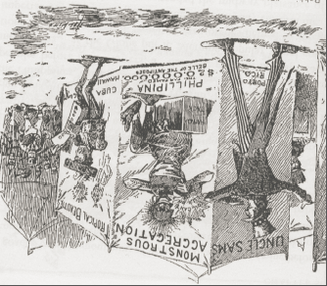[157]

This cartoon, entitled “Phillipina,” exhibits perhaps the most direct connection between imperialism and P.T. Barnum’s circus. By using the imagery of the circus, the artist was making the connection between human exhibition in commercialized entertainments and the way Americans viewed people from ‘uncivilized’ island nations. According to Miller, contemporary political cartoonists often “constructed the work of colonization as popular amusement.”[158] Published by the *Boston Herald* in December of 1898, this cartoon presents the viewer with an image that celebrates American imperialism by turning the United States’ conquest of the Philippines, Hawaii, Cuba, and Guam into a traditional freakshow. Essentially, the artist is suggesting that the United States’ imperialist actions overseas provided the opportunity to collect and exhibit human spoils of war for the entertainment of white Americans.

In the cartoon, the artist depicts Uncle Sam as a showman who is exhibiting people from America’s newly acquired territories under the circus tent. The main attraction is “Phillipina,” who is advertised as the “Monstrous Aggregate,” a clear reference to the freakshow tradition in American popular entertainment. By using the word “monstrous,” the artist implicitly suggests that the Filipino person on display is a monster and, therefore, a freak. The Filipino’s exhibition also includes a hyperbolic and clearly sarcastic description as the “$20,000,000 Belle of the Antipodes.” The twenty million dollars references how much money the U.S. spent on its war in the Philippines, and the “Bell of the Antipodes” is a condescending joke about the physical beauty of the Filipino woman on display. She is drawn black, with disheveled clothing and extremely unkept hair; a direct use of imagery from blackface minstrel shows. Next to the advertisement for “Phillipina” is an ad for the “Island Beauties” from Cuba, Hawaii, and Guam. Uncle Sam is depicted as the circus caller, yelling out to the crowd to come see the freaks that he had obtained through conquest. Though some of the imagery is derivative of other entertainment forms, like minstrels, it is clear that the artist here was making the connection between imperialism and the act of human exhibition in the American circus; an act and institution that were both heavily influenced by P.T. Barnum.

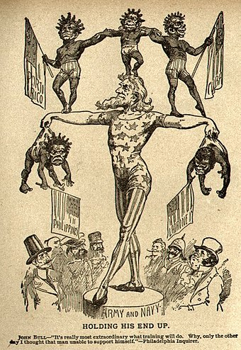[159]

This cartoon, entitled “Holding His End Up,” is another example of an artist directly referencing the American circus industry while remarking upon the subject of U.S. imperialism. Published August of 1899, this cartoon shows Uncle Sam in a leotard, standing atop a performer’s platform while supporting the weight of five child-like figures as a crowd watches. Each of the children are labeled as one of the territories that the U.S. had acquired during the course of the Spanish American War; namely, the Philippines, Hawaii, Cuba, Puerto Rico, and the Ladrones (Guam). [160] The message of the cartoon is clearly pro-imperialism, as the artist depicts Uncle Sam as a performer showing off his strength by holding up the five different nations. However, there is an implicit message regarding the consent of the various nations as Hawaii, Puerto Rico, and Cuba are standing atop Uncle Sam as if they were a part of the performance, whereas the Philippines and the Ladrones are being forcefully held up by their diapers. This depiction was undoubtedly commentary on the supposed lack of civilization among the Philippines and the Ladrones, as they are drawn as smaller and younger, and therefore less civilized, than the other three nations. The use of black children to represent these nations also exemplifies the fact that the artist was clearly attempting to infer that the young nations were inherently inferior to the white Uncle Sam. Like the previously discussed political cartoon, this cartoon also turns imperialism into a sideshow spectacle of human exhibition.

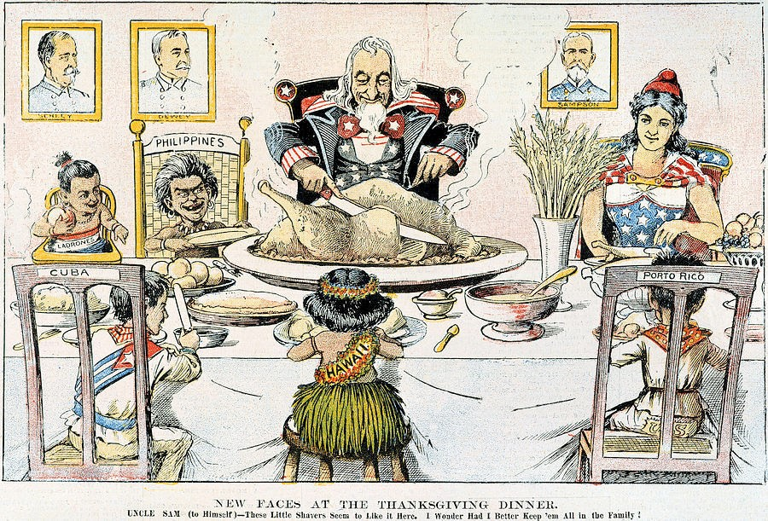[161]

This cartoon, entitled “New Faces at the Thanksgiving Dinner,” presents the viewer with a pro-imperialist image that is directly derivative of Barnum’s Ethnological Congress. In the cartoon, Uncle Sam and Columbia, who represent the U.S., have sat down to Thanksgiving Dinner with members of America’s newly acquired territories of Hawaii, Cuba, Puerto Rico, the Philippines and the Ladrones. The setting of the dinner table implicitly suggests that the artist was remarking upon the subject’s civilization.[162] In Western culture the act of eating dinner as a group often includes unspoken rules regarding etiquette, in which certain manners and customs at the dinner table are learned from an early age and are expected to be followed by all who sit down for a formal dinner. Knowing these manners and customs is incredibly important to ‘civilized’ society, so the use of the dinner table for this cartoon is not random; it is placing the caricatures of foreign nations into a space that is deeply reliant on Western tradition and customs.

Further, each caricature of the various countries in this cartoon was drawn with distinctive clothing and physical features that imply specific ideas about the country at large. All of the countries are drawn as children, therein implying that they were less civilized than their American hosts, but the disparate cultures are drawn at different developmental stages of their childhood. Cuba and Puerto Rico are drawn as prepubescent children who are fully clothed, implying that they were not quite as civilized as the Americans but they were not completely uncivilized savages. Though Hawaii is drawn with its back to the viewer, they are clearly a younger child who is dressed in a grass skirt and no shirt. The Philippines are also drawn as a young child without a shirt, and they are marked as distinctly different from Hawaii by the jewelry they are wearing and the messy hair. The Ladrones are depicted as an infant sitting in a high chair. These depictions suggest that the artist was remarking upon the various levels of civilization among the various countries, with the Ladrones being in their infancy of civilization, Hawaii and the Philippines just barely exhibiting any sort of civilization, and Puerto Rico and Cuba being well on their way to becoming civilized people of the world. The artist here is clearly celebrating the idea that the U.S. was going to ‘civilize’ the people in the various countries that it obtained through conquest. Like Barnum’s Ethnological Congress, this cartoon creates a spectacle out of foreign peoples that reduces their disparate cultures down to the clothes they wear.

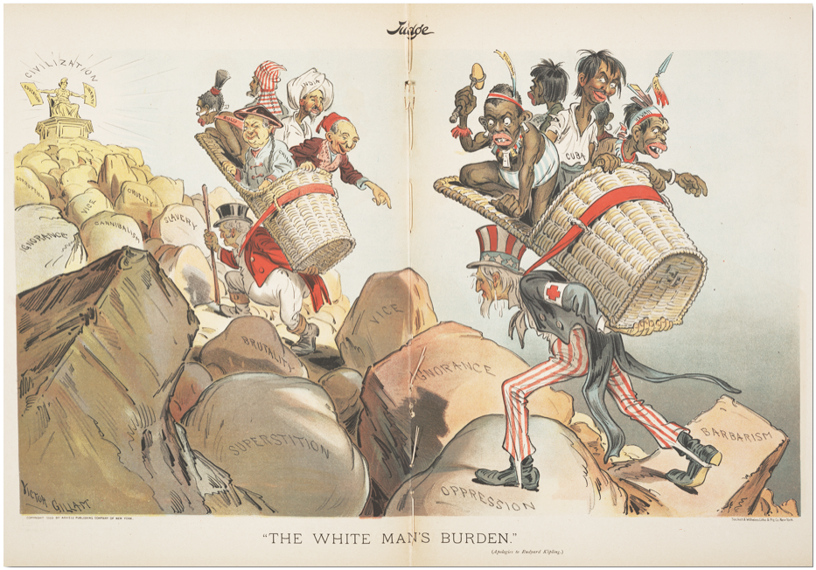[163]

This cartoon, published in April of 1899, further employs the imagery of the Ethnological Congress in order to validate U.S. imperialism.[164] In Barnum’ Ethnological Congress, people from all the “uncivilized, superstitious and savage people” were put on display for the entertainment of a white American audience.[165] In the cartoon, England and the U.S. are carrying dehumanized representations of their respective colonies, climbing rocks labeled Vice, Oppression, Superstition, Barbarism, Ignorance, Brutality, and Slavery on their way toward “Civilization.” The foreign nations in this cartoon, much like the previously discussed cartoon, are Barnumesque depictions of foreign peoples. Just like the “Ethnological Congress” each country is represented by a caricature of what Westerners believed to be the appropriate cultural clothing and artifacts. For example, the Chinese man has a rice hat on, the Indian a turban, and the Filipino is barely dressed and wielding a primitive weapon.

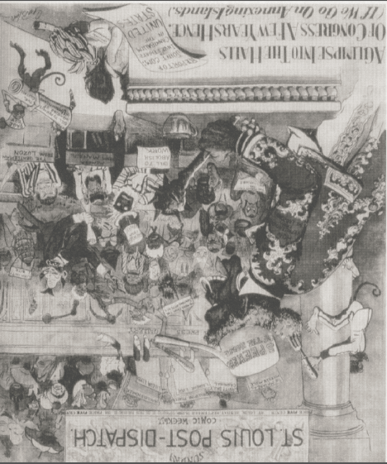[166]

This anti-imperialist cartoon, published in September of 1898, presents the viewer with another play on Barnum’s Ethnological Congress. In the cartoon, apelike men have taken over “Congress,” holding up signs calling to “abolish all work,” and “investigate cannibalism.”[167] According to Miller, this cartoon “echoed one of Barnum’s well-known exhibits in the late-nineteenth century, the ‘Ethnological Congress of Savage and Barbarous Tribes.’”[168] The cartoon also exploits the taboo subject of cannibalism; a characteristic that Barnum consistently worked to connect to foreign island peoples through the many iterations of his ‘cannibals from the South Pacific’ exhibitions. This cartoon also exploits American’s racism as the ape-like creatures who have taken over congress are derivative from the way black people were represented in contemporary cartooning and public entertainment. However, instead of remarking upon black culture, this image was created to directly imply that if the United States were to colonize foreign lands, then the foreign people would bring chaos, cannibalism, and savagery to the United States. The message of this cartoon, entitled “A Glimpse into the Halls of Congress a Few Years Hence (If we go on annexing islands),” is an explicit warning against what may come to pass if America continued to colonize ‘uncivilized’ lands and people.

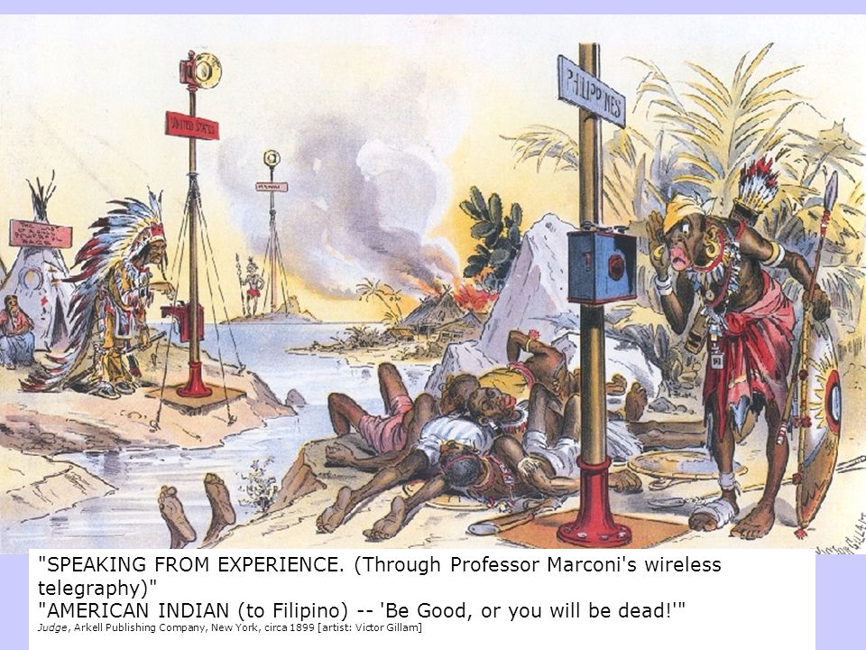[169]

This pro-imperialist cartoon also employs some of the aspects of the Ethnological Congress with its clear caricatures of foreign culture, but the depiction of the Filipino warrior also relies heavily on the island savage caricature that Barnum had curated through his cannibal exhibitions. Throughout his career, Barnum exhibited many different black-skinned, island ‘cannibals’ as a part of his freakshow. The ‘cannibals’ in these shows were always dressed in grass or animal hide skirts and holding primitive weapons. These characteristics of the cannibal became a staple of the island savage troupe in Barnum’s exhibitions, effectively creating imagery that audiences would quickly associate with cannibalism and a lack of civilization. In this cartoon, the Filipino is black, dressed in a skirt, and holding a primitive spear and shield.[170] The subjects of the cartoon are clearly on an island that is in disarray, and many of the Filipino’s countrymen have been killed. According to Miller, the artist, Victor Gillam, likely drew the Filipino as black because it related the Filipino people to a racial group that white Americans had dominated in the past, therefore implying that the Filipinos could easily be dominated.[171] While I would agree with this assessment to a certain extent, I do not consider it an irrelevant coincidence that black men and women had been put on stage as savage island cannibals for decades before this cartoon was published. By using the same imagery of the black islander that was popular in the public entertainment sector, Gillam was able to quickly exploit the various racial assumptions about civilization and savagery that were established by Barnum’s human exhibitions.

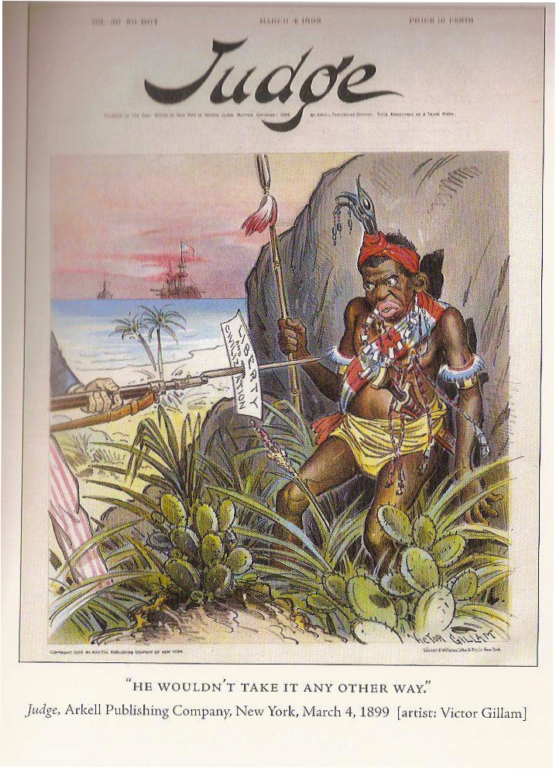[172]

This is another cartoon by Victor Gillam that employs on distinctly similar imagery of the island savage as the previous cartoon. Both images exhibit aspects of the Ethnological Congress as the subjects of the cartoons are drawn with specific clothing that denotes them as uncivilized. However, much like the previous cartoon, this image also depicts the Filipino in a way that appropriates the island savage imagery established by Barnum. The Filipino in this image is also drawn black, he is holding a spear, and he is dressed in colorful but primitive clothing. The scene taking place is clearly on an island as there is water and a ship in the background. Thus, this image is another depiction of the islander as uncivilized savage. Further, in the cartoon there is a direct acknowledgement of Gillam’s message about civilization for the cartoon includes a man, who one can only assume is Uncle Sam, holding a gun to a native Filipino with the words “Liberty and Civilization” at the end of a bayonet. The title of the cartoon, “He Wouldn’t Take It Any Other Way,” and the imagery of the Filipino being backed against a rock, effectively creates a sense of spectacle as if the viewer is watching a dramatic recreation of the moment that Filipinos realized that they would have to accept Western civilization or die. Although the imagery in this cartoon is directly Barnumesque, the use of drama to remark upon imperialism is a more indirect aspect of this image that could easily be linked to the spectacular exhibition of foreign cultures in Barnum’s public entertainments.

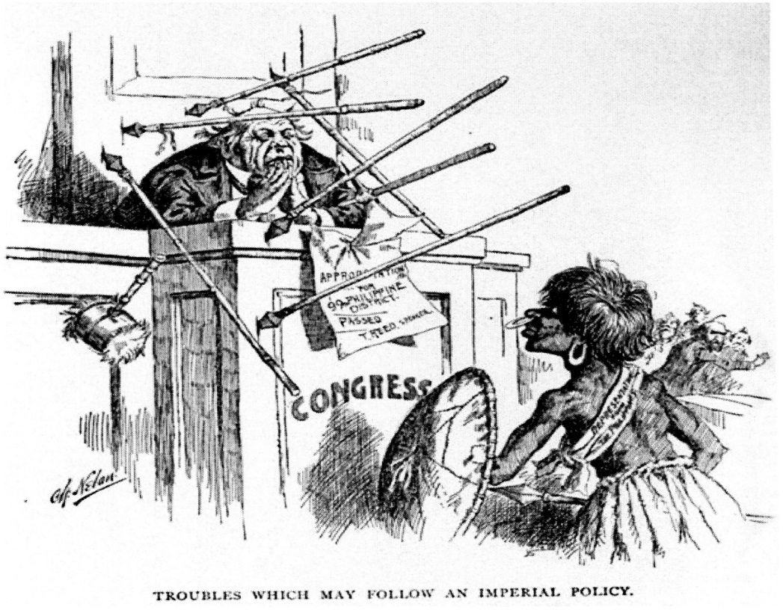[173]

Another cartoon that employs Barnum’s island savage imagery is “Troubles Which May Follow an Imperial Policy,” published by Charles Nelan. This cartoon depicts a native Filipino who is drawn black, with a large nose ring and a grass skirt. The Filipino in this image has apparently thrown several spears at a member of Congress, and the congressman has dropped his gavel, thereby insinuating that he has lost control of the government. This cartoon employs the same island savage imagery as the previously discussed cartoons, but the message of this image is entirely different. Instead of presenting the Filipinos with the island savage imagery in order to present them as uncivilized and in need of America’s help. Nelan used the island savage caricature to argue that the United States would be wasting its time trying to civilize such uncivilized people. This cartoon was meant to serve as a warning of what might happen if America continues on its path toward colonizing so-called ‘uncivilized’ people: the colonized may bring down the civilized institutions within the United States’ government.

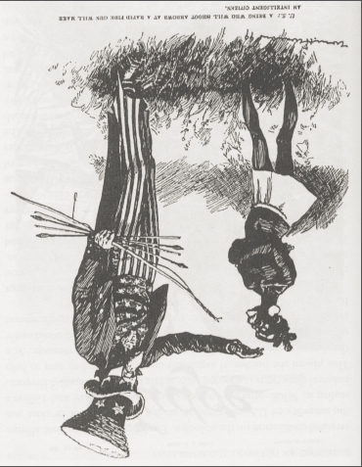 [174]

In this cartoon, published by *Life* magazine in 1899, the artist once again employs the black savage troupe to exhibit an argument against imperialism. In the cartoon, the figure representing the people in America’s proposed colonies is a stunted black person, with big lips and large hoop earrings. The figure is wearing a loin cloth, and is clearly agitated as Uncle Sam reaches down to pet him like an animal. Uncle Sam is holding a bunch of spears that the viewer can only assume were thrown at him by the black figure. This representation is not necessarily the exact same as the island savage, but the imagery is still heavily reliant on imagery popularized by P.T. Barnum. Beginning with the What is it? exhibit in 1860, Barnum had consistently put small, mentally handicapped black men on stage as the missing link in evolution. These shows were deeply racist, and heavily predicated on the audiences’ assumption that black people were scientifically inferior to white people. These shows were some of the most popular exhibitions in Barnum’s museum and circus, and the African savage was included in Barnum’s Ethnological Congress. As such, this artist exploited American racism toward black cultures, and applied it to foreign island nations, for this cartoon was printed to remark upon American imperialism in foreign island nations not in Africa.

In the end, though the messages of the various cartoons provided here differ, the imagery they used to depict island cultures was inarguably similar to the way islanders were exhibited in the nineteenth century commercialized entertainment industry. For half a century before these cartoons were published, P.T. Barnum was exhibiting people in his museum and circus that were tattooed by uncivilized savages in the South Pacific, who were ‘actual’ cannibals from Fiji, who were half-man-half-animal men from Borneo, who were missing links in evolution from Africa, and eventually, people who were simply exhibited because they were non-white and, therefore, ‘uncivilized.’ Throughout the nineteenth century, Barnum had popularized the image of the savage islander through his entertainment business to a point where the image of a black body in a grass skirt would have been rife with implicit messages regarding the subject’s civilization. Thus, it is no surprise that when the time came for the United States to invade foreign island lands, it was this long-established imagery that artists decided to use for their cartoons. In cartooning, the image must be quickly discernable and coded with all kinds of implicit messages. By using familiar depictions of foreign island peoples that people had seen in the circus, the artists were able to appropriate significant concepts about the foreigner’s ‘civilization,’ ‘inferiority,’ and ‘savagery.’ Cartoonists from this era could have chosen to depict island peoples in any way they saw fit, but, clearly, they chose to build their arguments on the strong, racist foundation that was built by Barnum and the circus industry.

**Conclusion**

On December 26, 1848, a newspaper in Louisiana, the *New Orleans Daily Crescent*, published an advertisement for the Olympic Circus that was performing in town. One of the main attractions for this circus was “James O’Connell, ‘The Tattooed Man” who would “make his first appearance” that evening.[175] Directly below this advertisement is an article entitled “The United States and Cuba,” in which a journalist was reporting on rumors that the United States was in talks with Spain about buying Cuba.[176] The rumors were false, and the United States did not procure the Spanish colony, but these two articles, almost touching on an obscure publication in 1848, provides an example of the coincidental connectivity one can find in researching historical events. For almost exactly fifty years after the articles’ publication, the United States did obtain ownership of Cuba after a propaganda campaign that was partly based on the fantasy of the island savage that James O’Connell helped create. This is not to say that James O’Connell in any way caused the conquest of Cuba, or any of the other Spanish colonies during the Spanish American War. This is merely an example of the serendipitous nature of history.

James O’Connell arrived in the United States in 1836, tattooed and ready to perform in New York’s burgeoning theater industry. He had arrived at the perfect time for his purposes, as theaters and dime museums were beginning to facilitate shows that exhibited the exotic and foreign practices of the outside world. O’Connell’s tattoos, and his story of captivity, made him a perfect candidate for a museum sideshow, and allowed the ex-sailor to speak to audiences about his experiences. Though the “Tattooed Man” did spend time in the far-away island of Pohnpei, his adventure story was likely filled will all kinds of hyperbole to make the performance more interesting. Regardless of the accuracy of his tale, O’Connell became the first person in the history of the American commercialized entertainment industry to take the stage and discuss the customs of foreign island cultures. With his tattoos and his claims of torture, adventure, and escape, O’Connell spent eighteen years traveling the theater circuit around the country until his death in 1854. Though references to O’Connell are typically found in obscure historical and anthropological scholarship, the influence the man had deserves more acknowledgement. For, after O’Connell’s seminal performances, the act of bringing ‘other’ peoples onto the American stage became common practice in the popular entertainment industry. O’Connell was not the cause of this phenomenon, but he should be understood as the canary in the cave. His career was, essentially, a microcosm of the way foreign island cultures would come to be represented in the popular entertainment industry for the following decades.

James O’Connell was the canary of the commercialized entertainment industry but P.T. Barnum was the cave. Early in his career, Barnum employed James O’Connell and quickly understood the value of exploiting his audiences’ fascination with the South Pacific and, really, all things ‘exotic.’ After Barnum exhibited O’Connell “The Tattooed Man,” the showman went on to exhibit island cannibals, missing links, descendants of ancient civilizations, wild humans, and many other freakshows that exploited his audiences’ fear and interest in all things ‘other.’ However, unlike the high-class museum, with its strict policy of education and moral uplift, Barnum’s exhibits were always presented with a tinge of truth and a litany of fantasy. Part of the showman’s draw was his “Operational Aesthetic” in which he tried to fool the audience and the audience tried to find the lie. As such, Barnum’s entertainments were extravagant and often ridiculous. This was not an issue for his audience though, as his American Museum was a space for entertainment, not enlightenment.

After Barnum’s museum burnt down in the late eighteen sixties, the showman moved to create a traveling version of his extravagant entertainments. Beginning in the eighteen seventies, Barnum’s Greatest Show on Earth, traveled to towns across America and Europe bringing with it the exhibition of all types of human exhibition. In the early years of Barnum’s circus, he continuously exhibited foreign bodies as a part of his freakshow, but he often included some type of signifier that they were dramatically different than his white audience: for example, they were cannibals, wild men, giants, dwarfs, and any and everything else that would denote them as different. However, during the late nineteenth century, Barnum began exhibiting a new kind of show, the Ethnological Congress, that was meant to exhibit all the uncivilized races of the world. Instead of these people having some sort of attribute that marked them as freak, these people were paraded out in front of a crowd simply because of their foreignness. Essentially, Barnum turned foreignness into a freakshow. The showman used contemporary pseudo-science, his white audiences’ feelings of racial superiority, and his own skills at creating a spectacle to turn his show into an exhibition of ‘otherness’ where audiences could gaze upon the uncivilized races of the world. Notably, this show came at a time when Americans adhered to the idea of Manifest Destiny: that the United States was destined to conquer all uncivilized peoples of the world. Essentially, these two factors were entangled in Barnum’s Ethnological Congress and made his show a celebration of conquest and cultural domination.

By the 1890s, Barnum was dead, leaving behind a legacy that cannot be overstated. His shows were seen by millions around the world, and scholars still consider the showman to be one of the most influential characters of the nineteenth century. Though his influence is typically relegated to the history of advertisement and the entertainment industry, his impact must also be understood in the context of United States imperialism. Barnum made a career out of exploiting the idea that foreign people were uncivilized and inherently inferior. The showman curated a multitude of human exhibitions that sought to play upon his audiences’ sense of racial superiority over the non-white peoples of the world. When the United States finally got their chance to invade foreign countries in 1898, it was the imagery of the foreign savage that Barnum had created that cartoonists used to remark upon the positive and negative aspects of imperialism. The imagery of the island cannibal, the wild men, the unevolved savage, the uncivilized foreigner all made their way into the political discourse about American conquest. Barnum’s intention was likely to simply entertain his audience, but by 1898 it is clear that the showman had created a lens through which American’s learned to view the foreign as inhuman, uncivilized, and inarguably inferior. This lens was then appropriated by artists to garner support for unabashed imperialism in foreign island nations.

Obviously, there is a multitude of reasons why the United States engaged in the Spanish American and Philippine American wars. Kristen Hoganson argues that the wars were a result of the work-class male population’s need to feel manly and dominant toward foreign cultures. Amy Greenberg Argues that the conflicts were an extension of the United States’ expansion west, and the contemporary concept of manhood and Manifest Destiny. Bonnie Miller suggests that the wars were popular among the American public due to effective messaging campaigns by U.S. newspapers and political cartoonists. Janet Davis argues that the circus industry turned imperialism into a spectacle and garnered public support for conquest because it became deeply linked to nationalism. These wars were the first instance of the U.S. expanding beyond the borders of North America, and, as such, the topic has been covered by hundreds of historians, each with their own arguments as to what caused the conflicts. My work does not add to the major arguments as to what caused the wars, it simply reveals a new point of origin regarding the imagery that was used to sell the wars to the American people. While some of the aforementioned authors mention P.T. Barnum, none of them mention James O’Connell. Barnum is clearly the most important character in this history, but it is important to note that he was not the first to exploit the fantasy of the island savage in the American popular entertainment industry.

Further, the previously discussed authors, when they do mention Barnum or the influence of the entertainment industry, typically conflate the histories of black Americans and Native Americans with the history of island peoples within the entertainment industry. Instead of providing analysis of how island cultures were represented, most often, authors tend to discuss their exhibition in the context of how black Americans and Native Americans were viewed in contemporary society. Though this is entirely warranted as there is clearly a connection between the way these groups were presented in the entertainment business, analyzing their exhibition in this way takes away from the fact that they were each distinctly different cultures. By focusing specifically on the way island cultures were exhibited in the popular entertainment industry, I hope to add to the scholarship by providing a more clear examination of how pro and anti-imperialist cartoonists appropriated imagery that had been established in commercialized spectacles for decades before it ever made its way into political cartoons.

The establishment of a popular culture within American society has inarguably lead to the dissemination of ideas about the foreign cultures that is shared among a mass populace. The fascination with the ‘other,’ the stranger, the foreigner, has been of interest to scholars throughout the history of the world, however, popular entertainment has done a much better job of influencing society’s ideas about the outside world. Academic fields such as Cultural Anthropology, History, Philosophy, Psychology, and Political Science all analyze the foundational differences between human beings in order to better understand the human condition. However, intellectual analysis, and respectful, accurate assessment of foreign cultures, regardless of the academic field, is often only consumed by a small percentage of any population. Millions of people a year do not go out and read the grand academic works of Edward Said or Michel Foucault. What they do is watch television, movies, and some still go to the theater for a play. Thus, even in today’s age with the internet and endless amounts of scholarly knowledge at our fingertips, popular culture succeeds where academia fails. Popular culture reaches the masses in numbers that academics could only dream of. And that is why entertainment culture is so important. It is through entertainment that millions of people are introduced to the world outside their own. As such, we must better understand how our popular culture and entertainment industries have influenced the way Americans view people they perceive to be different or ‘other.’

As American museums and circuses discussed ‘civilization’ throughout the late-nineteenth century, they were effectively implying that foreign, non-white nations were unlike the West, and so they were inferior. Using this method of representation, show managers turned foreignness into a spectacle that effectively dehumanized foreign people to the point where American citizens, who claimed to love liberty, were calling for the wanton domination of foreign lands. This dehumanization happened through the process of image making. When men like Barnum were curating their shows, they were not attempting to accurately and respectively exhibit people from another culture, they were intent upon exhibiting what made the foreign people different than the white audience. In essence, they were creating a caricature of foreignness that implied inferiority among foreign people. As such, the imagery of island cultures within the theater, museum, circus, world fair, and political cartooning was inherently similar in that it played upon its audiences’ sense of superiority. Every time Barnum put a “cannibal” on stage, the masses were ‘learning’ about the savage and primitive nature of the outside world. It is unsurprising that, when the opportunity arose to ‘civilize’ the foreigner through violent conquest, political cartoonists relied upon imagery that had been specifically developed to exemplify the uncivilized nature of non-white cultures.

**Bibliography**

**Secondary Sources:**

Adams, Bluford. *E Pluribus Barnum: The Great Showman and the Making of U.S. Popular Culture.* Minneapolis: University of Minnesota Press, 1997.

Avramescu, Cătălin. *An Intellectual History of Cannibalism*. Princeton: Princeton University Press, 2011.

Bederman*,* Gail. *Manliness and Civilization: A Cultural History of Gender and Race 1880-1917.* Chicago: University of Chicago Press, 1995.

Bogdan, Robert. *Freakshow.* Chicago: The University of Chicago Press, 1988.

Brooks, James. *Captives and Cousins: Slavery, Kinship and Community in the Southwest Borderlands.* Chapel Hill, NC: University of North Carolina Press, 2011.

Davis, Janet. *The Circus Age: Culture & Society Under the American Big Top.* Chapel Hill: University of North Carolina Press, 2002.

Dening, Greg. *Islands and Beaches: Discourses on a Silent Land: Marquesas 1774-1880.* Melbourne: University of Melbourne Press, 1980.

Gell, Alfred. *Wrapping in Images: Tattooing in Polynesia.* Oxford: Oxford University Press, 1993.

Gilman, Sander. *Difference and Pathology: stereotypes of Sexuality, Race, and Madness*. Ithaca: Cornell University Press, 1985.

Greenberg, Amy. *Manifest Manhood and the Antebellum American Empire.* New York: Cambridge University Press, 2005.

Halttunen, Karen. *Confidence Men and Painted Women: A Study of Middle-Class Culture in America*, *1830-1870*. New Haven, CT: Yale University Press, 1982.

Harris, Neil. *Humbug.* Chicago: University of Chicago Press, 1973.

Hoganson*,* Kristin. *Fighting for American Manhood: How Gender Politics Provoked the Spanish-American and Philippine-American Wars.* New Haven: Yale University Press, 1998.

Hunt, Michael. *Ideology and U.S. Foreign Policy.* New Haven: Yale University Press, 1987.

Levine, Lawrence. *Highbrow Lowbrow: The Emergence of Cultural Hierarchy in America*. Cambridge: Harvard University Press, 1988.

Lott, Eric. *Love and Theft: Blackface Minstrelsy and the American Working Class.* New York City: Oxford University Press, 1993.

Lowie, Robert. *The* *History of Ethnological* *Theory*. New York City: Farrar & Rinehart, 1975.

Miller, Bonnie. *From Liberation to Conquest: The Visual and Popular Cultures of the Spanish-American War of 1898.* Boston: University of Massachusetts Press, 2011.

Namias, June. *White Captives: Gender and Ethnicity on the American Frontier*. Chapel Hill, NC: University of North Carolina Press, 1993.

Parry, Albert. *Tattoo: Secrets of a Strange Art as Practiced by the Native of the United States.* New York City: Simon and Shuster, 1933.

Riesenberg, Saul. “The Tattooed Irishman,” *Smithsonian Journal of History*. no. 3 (1968).

Rydell, Robert. *All the Worlds a Fair: Visions of Empire at American International Exhibitions 1876-1916*. Chicago: University of Chicago Press, 1984.

Stanton, William. *The Great United States Exploring Expedition of 1838-1842.* Berkeley: University of California Press, 1975.

*Tattoo: Bodies, Art and Exchange in the Pacific and the West,* edited by Nicholas Thomas, Anna Cole, and Bronwen Douglas. London: Rektion Books, 2005.

Werner, Annie. “’Savage Printers’: Beachcoming, Tattoos, and Liminality in James O’Connell’s Residence,” published in *Something Rich and Strange.* Melbourne: Wakefield Press, 2009.

**Primary Sources**

“A Glimpse into the Halls of Congress a Few Years Hence.” *St. Louis Post Dispatch*, Sept. 18, 1898.

“Annexation in the Pacific.” *New York Daily Times;* Nov 11, 1851.

“Another Hoax,” *The New York Herald*, Feb. 27, 1836.

“Barnum and the Insurance Companies,” *New York Herald*, December 12, 1868.

“Barnum’s American Museum,” *New York Herald*, Nov 22, 1842.

“Cannibals in the Philippines,” *The Deseret Evening News* (Salt Lake City, UT), March 23, 1899.

“Disastrous Fire,” *New York Times*, July 14, 1865.

“For Retention: Prominent Men Who Favor Holding the Philippines,” *The Pacific Commercial Advisor* (Honolulu, HI), Nov. 2, 1898.

“Holding His End Up,” *Philadelphia Inquirer*, August 9, 1899.

“New Faces at the Thanksgiving Dinner.” *New York Journal*, c 1898. Found in: Mary Lou Beatty, *Humanities* 19, no. 1 (1998): 42.

“Philippine Cannibals,” *The Irish Standard* (Minneapolis, MN), April 15, 1899.

“Phillipina,” *Boston Herald*, December 4, 1898.

“The House Opera,” *New Orleans* *Daily Crescent*, September 13, 1852.

“The Last of the Fiji Cannibals,” *San Francisco Call*. March 13, 1898.

“The Olympic Circus.” *The New Orleans Daily Crescen*t, Dec. 26, 1898.

“The Science of Manifest Destiny.” *New York Daily Times (1851-1857);* Sep 9, 1852

“The United States and Cuba.” *The New Orleans Daily Crescent*, Dec. 26, 1898.

“Tragedy at the Opera House.” *New York Herald*, May 15, 1849.

“Treaty of Paris,” August 13, 1898. Loc.Gov.

“U.S. Senate: H.R. 10086 Declaration Of War With Spain, 1898," April 25, 1898. Senate.Gov.

Barnum, Phineas Taylor. *Struggles and Triumphs: Forty Years’ Recollection of P.T. Barnum*. Buffalo: Warren, Johnson & co., 1872.

Eisenmann, Charles. *Waino and Plutano*. c. 1870. Ronald G. Becker collection of Charles Eisenmann photographs, Special Collections Research Center, Syracuse University Libraries. Syracuse, NY.

*Figi Cannibals*, E. & H.T. Anthony. Print. New York, c. 1872.

Gillam, Victor. “He Wouldn’t Take it Any Other Way.” *Judge*, March 4, 1899.

Gillam, Victor. “Speaking from Experience.” *Judge*, April 22, 1899. Courtesy New York State Library, Manuscripts and Special Collections.

John C. Rives, *The Congressional Globe: Containing Speeches and Important State Papers for the First Session, Thirty-First Congress* (Washington D.C: City of Washington, 1850), Vol. 22.

Kipling, Rudyard. “The White Man’s Burden: The United States & The Philippine Islands, 1899.” Rudyard Kipling’s Verse: Definitive Edition (Garden City, New York: Doubleday, 1929).

Nations at the Fair,” *New York Times*, April 30, 1893.

Nelan, Charles “Troubles Which May Follow an Imperial Policy. c 1898. Courtesy of Richard Samuel West Collection, The Ohio State University, Billy Ireland Cartoon Library and Museum. Osu.Edu.

*New York Herald*, August 24, 1840.

*New York Herald,* May 12, 1849.

*New York Herald*, Nov. 11, 1849

*New York Herald*, November 22, 1842.

*New York Herald*, November 28, 1842.

O’Connell, James. *A Residence of Eleven Years in New Holland and the Caroline Islands.* Boston: B.B. Mussey, 1836.

O’Connell, James. *The Life and Adventures of James F. O’Connell, The Tattooed Man.* New York: Applegate, 1845.

O’Sullivan, John. “Annexation.” *The United States Magazine and Democratic Review 17*, New York: 1845.

*Philadelphia Public Ledger*, May 16, 1849.

*Tattooing of O’Connell and Keenan*, c. 1850, Woodblock Print. Loc.gov.

Victor Gillam, “The White Man’s Burden,” *Judge*, April 1, 1899.

Walker, William H., “A Being Who Will Shoot Arrows at a Rapid Fire Gun Will Make an Intelligent Citizen.” *Life* 33, April 20, 1899. 337.

*What We Know About Waino and Plutano, The Wild Men of Borneo* (New York City: Damon and Preets Printers, c. 1878).

1. Robert Bogdan, *Freakshow* (Chicago: The University of Chicago Press, 1988), 242. See also: Amelia Klem Osterud, *The Tattooed Lady; A History* (Maryland: Taylor Trade Publishing), 45. See Also: George Odell, *Annals of the New York stage*, Vol. 4 (New York City: Columbia University Press, 1928).
2. *New York Herald*, Nov. 11, 1849.
3. Bogdan 32
4. The 1876 Centennial Exhibition in Philadelphia was the first World’s Exhibition to include racial displays, but exploitation of race in the Columbian Exposition was much more pronounced and discussed among critics. Both events are worthy of analysis, but the Columbian is much more indicative of my argument.
5. Bogdan48
6. Gail Bederman*, Manliness and Civilization: A Cultural History of Gender and Race 1880-1917* (Chicago: University of Chicago Press, 1995), 5.
7. Ibid
8. Bluford Adams, *E Pluribus Barnum: The Great Showman and the Making of U.S. Popular Culture* (Minneapolis: University of Minnesota Press, 1997), 165.
9. Ibid, 165.
10. Adams, 180
11. Janet Davis, *The Circus Age: Culture & Society Under the American Big Top* (Chapel Hill: University of North Carolina Press, 2002), 194.
12. Ibid, 203.
13. Kristin Hoganson*, Fighting for American Manhood: How Gender Politics Provoked the Spanish-American and Philippine-American Wars* (New Haven: Yale University Press, 1998).
14. Amy Greenberg, *Manifest Manhood and the Antebellum American Empire* (New York: Cambridge University Press, 2005).
15. The most famous example of this is John Gast’s painting *American Progress*, published in 1872, which depicts America in the form of a woman, gliding across the land, bringing ‘civilization’ to the western frontier.
16. Greenberg, 12
17. Bonnie Miller, *From Liberation to Conquest: The Visual and Popular Cultures of the Spanish-American War of 1898* (Boston: University of Massachusetts Press, 2011).
18. Ibid, 189.
19. Ibid.
20. SanderGilman, *Difference and Pathology: stereotypes of Sexuality, Race, and Madness*, (Ithaca: Cornell University Press, 1985). Gilman’s influential work establishes the idea of the ‘other’ as a stereotypical version of a person that is unlike one’s self.
21. Bogdan, 26. The phrase ‘living curiosities’ comes from the early-eighteenth century tradition of traveling exhibitions as exhibitors would create signs that said “to the curious.” The phrase was later changed to ‘living curiosities’ to emphasize that the show included animals or people. “Living curiosities” would later become the preferred phrase for advertising freakshows throughout the nineteenth century.
22. Bogdan, 25.
23. Lawrence Levine, “William Shakespeare in America,” in *Highbrow Lowbrow: The Emergence of Cultural Hierarchy in America*, (Cambridge: Harvard University Press, 1988), 11-82.
24. Ibid, 21.
25. Similar to a theatrical performance in 2019, tickets to a theater were different depending on where the seat was. However, tickets to a play in the early-nineteenth century were still affordable for pretty much everyone. This inevitably led to class segregation among a three tiered seating system, including seats in the boxes, the pit, and the gallery. The rich sat in the box seats, the middle-class sat in the pit (in front of the stage), and the poor sat in the gallery (balcony seating). Levine, 24.
26. Ibid, 26.
27. Ibid.
28. Levine, 63.
29. Ibid.
30. Ibid, 64.
31. Ibid.
32. Levine, 64.
33. Ibid, 65.
34. “Tragedy at the Opera House.” *New York Herald*, May 15, 1849.
35. *New York Herald,* May 12, 1849.
36. *Philadelphia Public Ledger*, May 16, 1849.
37. Lawrence Levine, “Order, Hierarchy, and Culture,” in *Highbrow Lowbrow.*
38. Levine,147.
39. Neil Harris, *Humbug* (Chicago: University of Chicago Press, 1973), 78.
40. Greenberg, 12.
41. James O’Connell, *The Life and Adventures of James F. O’Connell, The Tattooed Man* (New York: Applegate, 1845), 30.
42. Pohnpei one of the four states included in the Federated States of Micronesia, an independent republic that is now an “associated state” connected to the United States.
43. Anthropologist, Saul Riesenberg, has suggested that O’Connell was actually a petty criminal who had been sent to Australia on one of England’s convict ships. Riesenberg has suggested that he made his way to Pohnpei after escaping from the convict colony. Found in: Saul Riesenberg, “The Tattooed Irishman,” *Smithsonian Journal of History*, no. 3 (1968): 1-17.
44. James O’Connell. *A Residence of Eleven Years in New Holland and the Caroline Islands* (Boston: B.B. Mussey, 1836), 102.
45. Ibid, 113.
46. Two of the most famous pieces of travel literature, *The Travels of Marco Polo*, (c. 1300), and *The Journal of Captain Cook's voyage round the world in HMS ENDEAVOUR, 1768-1771* (1771), both claim that people they met on their journeys were cannibals. There are endless examples of this trope in travel literature. For further reading: Cătălin Avramescu, *An Intellectual History of Cannibalism*, (Princeton: Princeton University Press, 2011).
47. O’Connell, 108.
48. Ibid, 109: For further reading regarding tattooing traditions of South Pacific Islanders: Alfred Gell, *Wrapping in Images: Tattooing in Polynesia* (Oxford: Oxford University Press, 1993). Greg Dening, *Islands and Beaches: Discourses on a Silent Land: Marquesas 1774-1880* (Melbourne: University of Melbourne Press, 1980.
49. O’Connell p. 115
50. Ibid
51. Ibid
52. O’Connell, 121.
53. Ibid, 232.
54. Ibid, 129.
55. O’Connell, 115.
56. Ibid, 186.
57. Ibid, 109. This statement is notably omitted from a shorter version of O’Connell’s story, entitled *The Life and Adventures of James F. O’Connell, The Tattooed Man* (New York: Applegate, 1845). This version of O’Connell’s story was only 30 pages, and it was distributed as a part of his sideshow performances. Thus, when O’Connell’s narrative was given to a freakshow audience, the humanity of the Pohnpeians was omitted.
58. O’Connell, 82.
59. Ibid, 82-85.
60. Ibid, 87.
61. During the early nineteenth century, philosophers and educated Europeans were heavily influenced by German Romanticism. This philosophy essentially glorified nature and pre-industrial societies. As such, romantic thinkers commonly viewed non-western, indigenous populations as “noble savages,” or “nature’s gentlemen.” Transcendentalist writers, like Ralph Waldo Emerson, were popular during the 1830s, and their work applied the ideas of Romanticism to their literary work. During the 1840s, there was a movement of anti-transcendentalist writers who believed that humans were base and evil. Writers like Edgar Allan Poe, Emily Dickenson, Herman Melville, and Nathaniel Hawthorne were the major writers of this movement. Melville’s Typee (1846) served to paint indigenous cultures as dangerous cannibals. Thus, whether it was his intention or not, O’Connell was engaging with this contemporary discourse regarding the goodness of humans, in which writers were using island natives to represent their prospective points. In Residence, O’Connell presents the reader with both the ‘good’ noble savages and the ‘bad’ base savage.
62. *Tattooing of O’Connell and Keenan*, c. 1850, Woodblock Print. Loc.Gov. This image is not the print that was included in the theater bill in 1837. That document is so distorted that it is hard to make out exactly what is happening. However, it is clear that women are holding the men down and tattooing them. This image, though the artist is unknown, was likely distributed during O’Connell’s later performances. The theater bill from 1837 can be found in *Tattoo: Bodies, Art and Exchange in the Pacific and the West,* edited by Nicholas Thomas, Anna Cole, and Bronwen Douglas (London: Rektion Books, 2005) 87.
63. Thomas, *Tattoo*, 87.
64. Albert Parry, *Tattoo: Secrets of a Strange Art as Practiced by the Native of the United States* (New York City: Simon and Shuster, 1933), 65.
65. *Documentary on One*. “The Tattooed Irishman.” Produced by Joe Kearny and Liam O’Brien. RTE Radio 1, Nov. 11, 2017. This information comes from a radio documentary by an Irish radio station RTE Radio 1. The documentary is about James O’Connell and the three scholars mentioned all agree during interviews within the documentary that O’Connell’s depiction of tattooing and culture in his book were relatively accurate. Lars Krutak is an anthropologist that studies and has written multiple books about tattooing traditions of non-western cultures. Annie Werner is an Australian historian whose work on O’Connell entitled, “*’Savage Printers’: Beachcoming, Tattoos, and Liminality in James O’Connell’s* Residence,” was published in *Something Rich and Strange* (Melbourne: Wakefield Press, 2009). Juniper Ellis is an English professor that studies literature*.* Herbook *Tattooing the World: Pacific Designs in Print and Skin* (2008), investigates how pacific tattooing traditions have been represented in western culture.
66. Sideshows were performances that would come on to entertain crowds during the breaks intermission of a larger theatrical play. Sometimes these were jugglers, acrobats, or magicians, other venues used freakshows as their sideshow performances.
67. *New York Herald*, August 24, 1840.
68. *New York Herald*, November 22, 1842.
69. Ibid
70. *New York Herald*, November 28, 1842.
71. O’Connell’s story is most relatable to the captivity narrative tradition in American literature. The first captivity narrative in America, *A Narrative of the Captivity and Restoration of Mrs. Mary Rowlandson*, was published in 1682, and told the story of an English colonist who was taken captive by Native Americans during King Philip’s War. Following Rowlandson’s seminal work, thousands of European colonizers published narratives following their own captivity. The genre of captivity narrative can be found throughout the eighteenth, nineteenth, and twentieth centuries in American popular culture. For further reading about captivity, see: James Brooks, *Captives and Cousins: Slavery, Kinship and Community in the Southwest Borderlands* (Chapel Hill, NC: University of North Carolina Press, 2011). For further reading regarding captivity narratives, see: June Namias, *White Captives: Gender and Ethnicity on the American Frontier* (Chapel Hill, NC: University of North Carolina Press, 1993).
72. “The House Opera,” *New Orleans* *Daily Crescent*, September 13, 1852.
73. Ibid.
74. Ibid.
75. “The House Opera,” *New Orleans Daily Crescent*, Sept. 13, 1852.
76. Barnum is an instrumental figure in the history of advertising. He made a career advertising everything he did as the greatest, best, most extravagant thing anyone had ever seen. The type of hyperbolic advertisement that Barnum established in his museum and circus inspired countless others to employ similar practices. Further, Barnum’s circus was the largest traveling circus to date during the late nineteenth century. As such, the American military sent commanders to watch how he was able to transport such a large exhibition so efficiently. His methods also paved the way for other major traveling exhibitions such as Bill Cody’s Wild West Show.
77. Harris, 40.
78. Ibid, 37.
79. Harris, 42.
80. Ibid, 36
81. Ibid, 57.
82. Harris, 26.
83. Adams, 2-3. Further, Adams does an excellent job of explaining how Heth’s exhibition played into the contemporary discourse regarding slavery. For Adams, Barnum used Heth to push an anti-abolitionist message.
84. “Another Hoax,” *The New York Herald*, Feb. 27, 1836.
85. Harris, 25.
86. “Another Hoax”
87. Harris, 23.
88. Ibid, 40.
89. “Barnum’s American Museum,” *New York Herald*, Nov 22, 1842.
90. In the 1830s, American academics had yet to create a field of study for the analysis of culture. Ethnology, the precursor to Anthropology, was founded in 1842 with the establishment of the American Ethnological Society. Thus, it is unlikely that there were any lectures about foreign cultures in museum lecture halls by the time O’Connell took the stage for the first time. Further, captivity narratives consistently discussed the culture of Native Americans, but that was always in print rather than performance. For further reading: Robert Lowie, *The* *History of Ethnological* *Theory*, (New York City: Farrar & Rinehart, 1975).
91. Bogdan, 179.
92. Ibid, 179.
93. Ibid.
94. James Cook was an English explorer who ‘discovered’ many of the islands in the South Pacific. His discovery led to the colonization of many of the South Pacific islands, and his journals were well respected in the academic community. Cook died in Hawaii while attempting to arrest an island chief.
95. Bogdan 179
96. Ibid, p.179. Vendovi was a native of Fiji who had been ‘arrested’ by Charles Wilkes during the United States Exploring Expedition 1838-1842 for the murder of two American sailors, including Wilkes’ nephew Henry, a few years prior. Vendovi died upon arrival to New York, likely due to tuberculosis. For further reading: William Stanton, *The Great United States Exploring Expedition of 1838-1842* (Berkeley: University of California Press, 1975).
97. Adams, 166.
98. Bogdan, 31.
99. Adams, 166.
100. John O’Sullivan, “Annexation,” *The United States Magazine and Democratic Review*, Volume 17 (New York: 1845), 5-6, 9-10.
101. O’Sullivan.
102. “The Science of Manifest Destiny.” *New York Daily Times (1851-1857);* Sep 9, 1852.
103. Ibid.
104. Ibid.
105. “Annexation in the Pacific.” *New York Daily Times;* Nov 11, 1851.
106. Ibid
107. “Disastrous Fire,” *New York Times*, July 14, 1865.
108. “Barnum and the Insurance Companies,” *New York Herald*, December 12, 1868.
109. Harris, 242. Janet Davis agrees with this assessment and claims that the military actually sent people to watch the circus move from city to city to gather ideas for more efficient military mobilization.
110. *Figi Cannibals*, E. & H.T. Anthony. Print. New York, c. 1872.
111. *History of P.T. Barnum’s Fiji Cannibals (1872)*, found in Bogdan, 180.
112. Bogdan, 180.
113. Charles Eisenmann, *Waino and Plutano*. c. 1870. Ronald G. Becker collection of Charles Eisenmann photographs, Special Collections Research Center, Syracuse University Libraries. Syracuse, NY.
114. Bogdan, 123.
115. Ibid.
116. *What We Know About Waino and Plutano, The Wild Men of Borneo* (New York City: Damon and Preets Printers, c. 1878).
117. Bogdan, 123.
118. Ibid, 124.
119. This is in reference to Barnum’s ‘What is it?’ exhibit, in which he put a mentally handicapped black man named William Johnson in a furry suit and claimed that he was the missing link in evolution. This show is one of Barnum’s most infamous racial displays.
120. This show was called the “Living Aztec Children” and Barnum dressed up two mentally handicapped people from South America and claimed that they were the last descendants of the Aztec peoples.
121. Phineas Taylor Barnum, *Struggles and Triumphs: Forty Years’ Recollection of P.T. Barnum* (Buffalo: Warren, Johnson & co., 1872), 349.
122. Adams, 181.
123. Ibid
124. Adams, 183.
125. Ibid.
126. Ibid.
127. Barnum, *Struggles*, 627.
128. Adams, 193.
129. Robert Rydell, *All the Worlds a Fair: Visions of Empire at American International Exhibitions 1876-1916*, (Chicago: University of Chicago Press, 1984).
130. Rydell, 2.
131. Ibid.
132. Ibid.
133. Adams, 193.
134. “Nations at the Fair,” *New York Times*, April 30, 1893.
135. Bederman, 35.
136. Ibid.
137. Bederman, 35.
138. Adams, 194.
139. "U.S. Senate: H.R. 10086 Declaration Of War With Spain, 1898," April 25, 1898. Senate.Gov. Accessed Feb. 22, 2019. https://www.senate.gov/artandhistory/history/common/image/HR10086_Spanish-American-War.htm.
140. Some of the first examples of Congressmen calling for expansion into Cuba and the South Pacific comes from a discussion in Congress regarding the Missouri Compromise. The Compromise was passed in 1819, but as America began expanding West and gathering new territories, the question of whether slavery would be allowed in those places became a hotly debated topic in Congress. In 1850, the 31st congress of the United States began debating the slavery question because of the annexation of California. Within this discussion, representatives such as Georgia Representative Marshal Johnson Wellborn argued that the Mason Dixon line should be extended past the borders of North America so that when America expanded into Cuba and the South Pacific, they could create slave colonies. The topic of expansion and slavery in Cuba and South Pacific Islands is mentioned by a wide variety of representatives of the 31st Congress, which can be found in: John C. Rives, *The Congressional Globe: Containing Speeches and Important State Papers for the First Session, Thirty-First Congress* (Washington D.C: City of Washington, 1850), Vol. 22.
141. General Weyler’s “Reconcentration Policy,” refers to military tactics by the Spanish General in which he declared that all Cuban citizens leave their homes and live in what were effectively concentration camps. He instituted this policy to combat guerilla warfare in the country, however, he did not plan for how to feed or house the hundreds of thousands of people that would be populating the camps. As a result, hundreds of thousands died from disease and hunger. See: Miller, 21.
142. Miller, 7.
143. “Treaty of Paris,” August 13, 1898. Loc.Gov.
144. Miller, 123.
145. Ibid.
146. Ibid.
147. Ibid, 126.
148. Ibid, 123-126.The United States attempted to garner public support for the annexation of Hawaii in 1854, 1896, 1893, and 1897 but none of those efforts were successful. American missionaries and businessmen, namely the Dole family, had been actively involved in a coup to overthrow the queen of Hawaii, Lydia Kamakaeha, and instill a government that was favorable to American business interests. The Dole family had established a successful sugar industry on the island, and annexation was just the next move to make American control of the island official.
149. Ibid, 124.
150. “For Retention: Prominent Men Who Favor Holding the Philippines,” *The Pacific Commercial Advisor* (Honolulu, HI), Nov. 2, 1898.
151. Hoganson, 133.
152. Miller, 20.
153. Ibid, 139.
154. For further reading: Eric Lott, *Love and Theft: Blackface Minstrelsy and the American Working Class* (New York City: Oxford University Press, 1993).
155. For further reading regarding ideology with regards to American imperialism, see: Michael Hunt, *Ideology and U.S. Foreign Policy* (New Haven: Yale University Press, 1987).
156. Hoganson, 133-136. Hoganson discusses contemporary groups in America that were anti-imperialist because the idea of imperialism went against the main ideas of what the United States was supposed to stand for. These groups claimed that the people of Cuba, Hawaii, Puerto Rico, and the Philippines deserved their freedom just like the Americans did after the revolution. However, in my research I have not been able to find political cartoons that express this sentiment. These groups likely made their arguments through protests and newspaper articles, not through cartoons.
157. “Phillipina,” *Boston Herald*, December 4, 1898.
158. Miller, 225.
159. “Holding His End Up,” *Philadelphia Inquirer*, August 9, 1899.
160. The Ladrones is an old name for the Mariana Islands which lay just east of the Philippines. The territory that the United States took control over that was once called the Ladrones is now called Guam.
161. “New Faces at the Thanksgiving Dinner.” *New York Journal*, c 1898. Found in: Mary Lou Beatty, *Humanities* 19, no. 1 (1998): 42.
162. Books and manuals that explain proper dining etiquette in American households have been published throughout the nineteenth, twentieth and twenty-first centuries. The importance of manners and customs has been a part of aristocratic culture in Western societies for centuries. However, after industrialization, and the growth of the working class, manners became especially important in large American cities as con men and women tried to infiltrate high society to take advantage of people. Etiquette was one of the most effective tools that the bourgeoisie could use in the mid-nineteenth century to expose a conman/woman. This made etiquette and manners extremely important for the people in this era. For further reading: Karen Halttunen, *Confidence Men and Painted Women: A Study of Middle-Class Culture in America*, 1830-1870, (New Haven, CT: Yale University Press, 1982).
163. Victor Gillam, “The White Man’s Burden,” *Judge*, April 1, 1899.
164. This cartoon represents the pro-imperialist concept of “The White Man’s Burden,” which is also the title of the piece. “The White Man’s Burden,” was a poem written by Rudyard Kipling in February 1899 which called for the American government to take up the burden of ‘civilizing’ foreign peoples, just as England had done with its colonies. See: Rudyard Kipling, “The White Man’s Burden: The United States & The Philippine Islands, 1899.” Rudyard Kipling’s Verse: Definitive Edition (Garden City, New York: Doubleday, 1929).
165. Adams, 175.
166. “A Glimpse into the Halls of Congress a Few Years Hence.” *St. Louis Post Dispatch*, Sept. 18, 1898.
167. Cannibalism had been a common topic when discussing island nations throughout the 1850s, 60s, and 70s, however, the topic began to creep back into newspaper articles in the 1890s when journalists were discussing imperialism. Claims of indigenous peoples in the Philippines engaging in the act of cannibalism can be found in multiple papers during the late-1890s. See: “The Last of the Fiji Cannibals,” *San Francisco Call*. March 13, 1898. See also: “Philippine Cannibals,” *The Irish Standard* (Minneapolis, MN), April 15, 1899. See also: “Cannibals in the Philippines,” *The Deseret Evening News* (Salt Lake City, UT), March 23, 1899.
168. Miller, 225.
169. Victor Gillam, “Speaking from Experience.” *Judge*, April 22, 1899. Courtesy New York State Library, Manuscripts and Special Collections.
170. The image of the Filipino is also drawn in the style of the blackface minstrel, but, as I have mentioned before, this was likely done in order to establish the fact that the Filipinos were not white rather than remarking on black culture.
171. Miller, 195.
172. Victor Gillam, “He Wouldn’t Take it Any Other Way.” *Judge*, March 4, 1899.
173. Charles Nelan. “Troubles Which May Follow an Imperial Policy. c 1898. Courtesy of Richard Samuel West Collection, The Ohio State University, Billy Ireland Cartoon Library and Museum.Osu.Edu.
174. William H. Walker, “A Being Who Will Shoot Arrows at a Rapid Fire Gun Will Make an Intelligent Citizen.” *Life* 33, April 20, 1899. 337.
175. “The Olympic Circus.” *The New Orleans Daily Crescen*t, Dec. 26, 1898.
176. “The United States and Cuba.” *The New Orleans Daily Crescent*, Dec. 26, 1898.